The theme: Invitation.

The educational aim: a) to explain the new words.
b) to read and translate the dialogue.
c) to do oral and written exercises.

The developing aim: to enrich pupils’ vocabulary stock, to develop their
skills and habits of speaking, listening, writing and
reading and their abilities of independent thinking.

The aim of up-bringing: to teach pupils to be friendly and respect each other,
to motivate pupils’ interest in learning English.

The type of the lesson: mixed.

The method of the lesson: an interactive.

The equipment: pictures, tables, cards, a computer, a multi projector, a CD,
magnet board, text book.

The procedure of the lesson:

- The beginning of the lesson
  - Greeting pupils.
  - Psychological preparing of pupils for the lesson:
You are as happy and clever as this child, you are as beautiful as the
Sun, and you will fly high as these birds.
  - Talking with the pupil on duty about the day, date, weather and
season and marking absentees.
  - To write a quiz: древний-ancient, воздух-air, солнечный-sunny,
изменчивый-changeable, путешествие-journey, светить, сиять-to
shine, головная боль-headache, грипп-flu, мусор-litter,
наказать-to punish.
  - To retell about Karnak:
Every person has his native town or village. My native village is Karnak. Karnak is an ancient village. It situated near the mountain of Karatau. The population of Karnak is over 14 000 people. The people of my village are kindly and friendly. There are four schools, a hospital, kindergartens, a lot of shops, a club and other buildings in it.

To retell about weather:
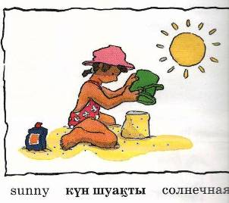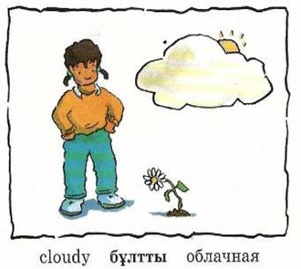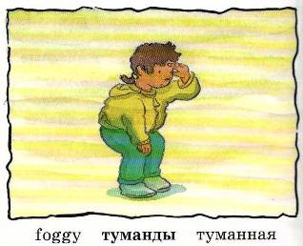
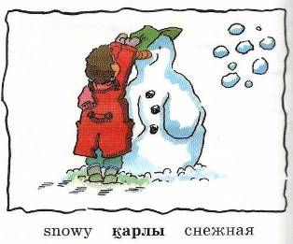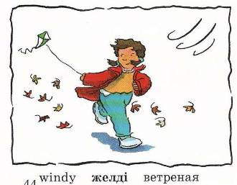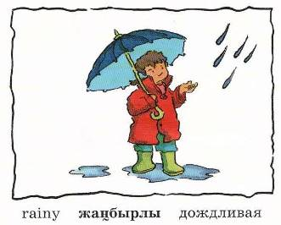

There are four seasons in a year. The weather is different in each season.
In winter the ground, houses and the trees are white with snow. It is cold and people put on their warm clothes when they go out.
Boys and girls like to skate and ski. They run and jump in the snow or play snowballs. Little children like to make a snowman.
The weather of the spring is changeable. It is warm in this season. It is often cloudy and rainy in the spring.
The sun is shining brightly and it is usually very hot in summer.
It often rains in autumn. Sometimes it is windy and sometimes foggy

When the weather is wet
We must not fret; -

When the weather is cold
We must not scold –

When the weather is warm
We must not storm, -
But be thankful together
Whatever the weather.

  - To work with the cards.
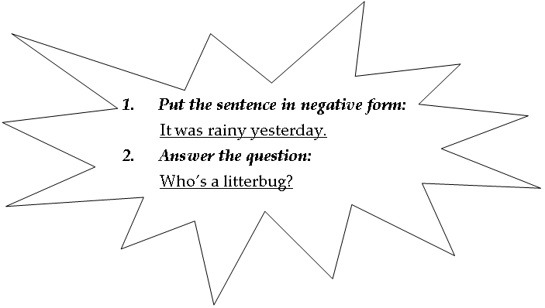
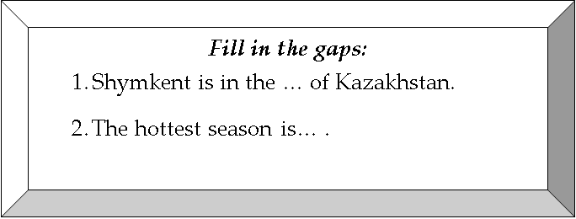
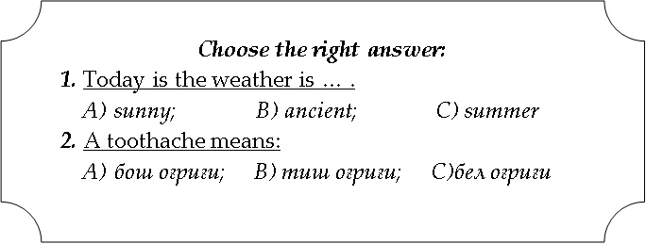

  - To review the word building.

Noun | adjective
Wind | windy
Friend | friendly
Success | successful
Industry | industrial
Noun |  | verb
punishment |  | to punish
teacher |  | to teach
organization |  | to organize
pollution |  | to pollute

To complete the last lesson

- The main part of the lesson.
The new lesson: Unit 6. Step1. Invitation.

- To solve a crossword: Write the opposites of the words.

 | 1 | B | O | R | I | N | G
 |  |  |  | 2 | N | E | W
 | 3 | H | E | A | V | Y
 |  |  |  | 4 | I | L | L
 |  |  |  | 5 | T | A | L | L
 |  | 6 | S | T | A | R | T
 | 7 | L | I | T | T | L | E
 |  |  | 8 | G | I | V | E
 |  |  | 9 | G | O | O | D
10 | C | L | E | A | N

- INTERESTING
- OLD
- LIGHT
- HEALTHY
- SHORT
- FINISH
- MUCH
- TAKE
- BAD
- DIRTY

- To explain the new words:
an invitation | [inviteiʃǝn] | Приглашение, пригласительный билет
disgusting | [disg’ʌstiƞ] | отвратительный
delicious | [diliʃǝs] | Очень вкусный
a postcard | [pǝustkα:d] | открытка
lovely | [‘lʌvli] | прекрасный
boring | [‘bɔ:riƞ] | скучный

- To make up sentences
I send a postcard to my friend.
I enjoyed my winter holidays.
Ice-cream is delicious.
Today the weather is lovely.
This book isn’t boring, it’s interesting.

- Physical minute
Stand up and look around
Shake your head and turn around.
Stamp your feet upon the ground.
Clap your hands and then sit down.
Stand up and look around.
Make a bow and turn around.
Stamp your feet upon the ground
Clap your hands and then sit down.

- Phonetic exercise.

delicious | John
disgusting | enjoy
invitation | food
boring | were
March | party

[ʃ]_____________________________
[ɔ:]_____________________________
[ʌ]_____________________________
[ǝ:]_____________________________
[α:]_____________________________

- How to write an invitation?

Nafisa

I invite you to my
Party
At 15 Turkestan St.
On Friday
3 February
At 6 p.m.

Zulkhumar

To Shadiyar
From Dilnur

Please come to my
party on
4 February at 7 p.m.
Address:
5 Amir Temur St.
I hope you
can come

Pupils will write their own invitations.

- To listen to the dialogue over the computer.
Carol: Were you at John’s party?
Dmitry: Yes, I was.
Carol: Was it good?
Dmitry: No, it was boring. The food was disgusting.
Carol: Were there many people?
Dmitry: Yes? There were. And where were you?
Carol: I was at Tom’s party. There were not many people there. But it was
lovely. The food was delicious. I enjoyed it.

- To read and translate the dialogue.

- To do an oral exercise. Are the sentences true (T) or false (F) according the dialogue?
- Dmitry was at John’s party yesterday.
b. The party was boring.

d. There were many people.
c. The food was delicious.

f. The food was disgusting.
e. Carol was at John’s party too.

g. Carol enjoyed the party.

True
_____
_____
_____
False
_____
_____
_____

_____ _____
- To write the exercise 7 on p.98. To interview the partner.
- Were you at a party yesterday?
Nilufar was at a party yesterday.
- Was it good?
It was good.
- Were there many people?
There weren’t many people.
- And where were you?
She was at Hayat’s party.

- The end of the lesson
- To finish the new lesson.
To use the proverb: “Knowledge is power”.
Knowledge is an important thing in our life. Good knowledge of school subjects will help you later to choose your way in life. You learn many things at you lessons. And you also get new information from books, magazines, radio and TV programmes.
Knowledge helps us to make our work more effective, more useful.

- Marking pupils and comment on marks.

- Giving homework: to write about your friend’s birthday party.

