Разработка урока английского языка для 8 класса
«Your Own Game»
«Music in our life»

Учитель английского языка:
Абрамова Елена Борисовна
МОУ СОШ №21 с УИОП
г. Раменское
2013г.

Цель: актуализация изученного материала, расширение кругозора, развитие воображения, стимулирование интереса учащихся к изучению английского языка.
Оборудование: плакаты с вопросами для игры, карточки с заданиями, наглядные пособия (рисунки).
Технологии: коммуникативные, групповые, здоровьезберегающие, игровые.
УМК: любой.

ХОД МЕРОПРИЯТИЯ

- Hello, dear boys and girls. I am glad to see you today, my dear friends. Do you like to play games? Today you’ll have a chance to take part in our game. We’ll have 2 stages. Each stage will have 5 topics. Each topic includes 5 questions. Each question has its price (10, 20, 30, 50, 100). You will try to get as many points as you can.
Учитель приветствует учащихся и сообщает им о проведении мероприятия «Своя игра» по теме «Музыка в нашей жизни». Данная игра проводится по правилам, аналогичным телевизионному варианту. В игре принимают участие 10-15 человек. Можно провести это мероприятие среди параллели учеников 8 классов, предварительно предупредив их, что состав команды 4-5 человек, не более. Участники отвечают на предложенные вопросы и в случае правильного ответа получают очки, которыми оценивается данный вопрос. Игра состоит из двух туров. В каждом туре участникам предлагаются вопросы по 5 темам. Каждая тема содержит 5 вопросов. Команда, набравшая наибольшее количество баллов – побеждает и получает грамоту за 1 место.
Musical  instruments | 10 | 20 | 30 | 50 | 100
Russian music | 10 | 20 | 30 | 50 | 100
American singers | 10 | 20 | 30 | 50 | 100
British singers | 10 | 20 | 30 | 50 | 100
Different kinds  of music | 10 | 20 | 30 | 50 | 100

STAGE 1
(General information)

Musical instruments: What kind of musical instrument do you see in the picture?
10 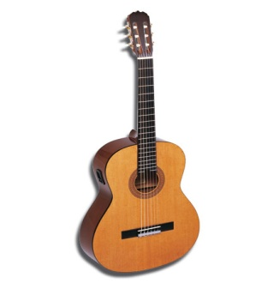(The guitar) | 20 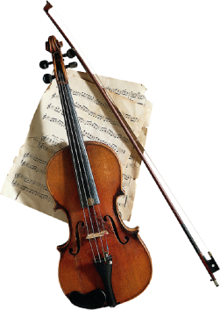(The violin)
30 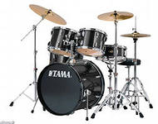(The drums) | 50 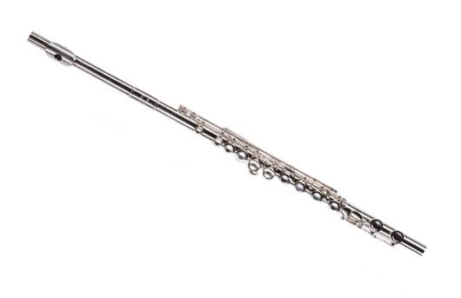(The flute)
100 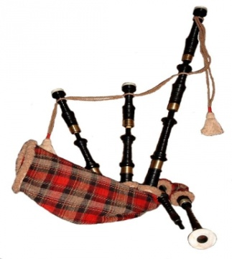 (The bagpipe)

Russian music:
10 – Who created the music foe the ballets “The Swan Lake”, “The Sleeping Beauty” and “The Nutcracker”? (Peter Tchaikovsky)
20 – Who is the composer of the first Russian opera “Ivan Susanun”? (Michael Glinka)
30 – Who is the composer of the song “Moscow Suburb Nights”? (Soloviov - Sedoy)
50 – He had an ability of combining satire and lyricism in the same line in his songs. His first collection of poems “Songs of the Russian Bards Texts” appeared after he had died. (Vladimir Vysotsky)
100 (The cat in the sack) – Who created the music for the opera “Boris Godunov”? (Modest Musorsky)

American singers:
10 – He is only 18. He is a Canadian pop musician. He was discovered in 2008. He has sold 15 million albums. He has got a lot of fans among girls-teenagers. (Justin Bieber)
20 – She was born in August 16, 1958. Now she is 54. She is an American singer, songwriter, actress, director and dancer. She is the best-selling female artist of the 20th century and the top selling female artist in the US with 85 million certified records. (Madonna)
30 – He was born in August 29, 1958 and died in June 25, 2009. He was an American recording artist, actor, businessman, singer-lyricism and philanthropist often referred to as the “King of the Pop”. (Michael Jackson)
50 – She is only 26. Her true name is Stefani Joanne Angelina Germanotta. She is an American singer, songwriter and dancer. Her public image is as shocking as her clothes. (Lady Gaga)
100 – His songs started a new period in the American music. He brought the music sounds of the blacks in America and of the country people. He was known “The king of rock-n-roll”. (Elvis Presley)

British singers:
10 – She is an English businesswoman, fashion designer and singer. In the late 1990s she sang in the well-known pop-group. Her husband is a famous football player. (Victoria Beckham)
20 – He was an English musician singer and songwriter. He died in 1980 at the age of 40. He was one of the legend group of four from Liverpool. (John Lennon)
30 – She is only 24, but she is very famous nowadays. Her career has begun in 2006, but thanks for her single “Skyfall” she’s become famous all over the world. (Adele)
50 (Your own game) – He is an English rock singer, songwriter, composer, pianist and occasional actor. He was named a Disney Legend for his numerous outstanding contributions to Disney’s films and theatrical work. He is the author of the legend soundtrack for the cartoon “The Lion King”. (Elton John)
100 – Now she is 73. One of world’s most popular entertainers, she has been called the most successful female rock artist, winning 8 Grammys and selling more concert tickets than any other solo performer in history. Her single “Golden Eyes” was written as a soundtrack for the film “James Bond” in 1995. (Tina Turner)

Different kinds of music:
10 – It is a genre of music which originated in its modern form in 1950s. This music is intended to encourage dancing or it uses dance-oriented beats of rhythms. (pop music)
20 – It is a genre of popular music originated in 1950s. Musically it has concentrated around the electric guitar, usually as part of such group with bass guitar and drums. (rock music)
30 – It is a musical form that grew out of a cross-fertilization of folk blues, rag time and European music, particularly band music has been called the first art form to develop in the USA. (jazz)
50 – It is the art music produced in the traditions of Western liturgical and secular music, encompassing a broad period from naughty the 11th century to present times. The instruments used in it are such as piano, harpsichord, organ and others. (classical music)
100 – It is the genre of music that was born in 1950s in America. The main characteristics of this music are: a fast rate, extensive use of youth slang, relaxedness musical instruments are guitar, bass, drums and piano. (rock-n-roll)

STAGE 2
(Lexical and Grammar Rules)

Questions | 10 | 20 | 30 | 50 | 100
Listening | 10 | 20 | 30 | 50 | 100
Reading | 10 | 20 | 30 | 50 | 100
Vocabulary | 10 | 20 | 30 | 50 | 100
Grammar | 10 | 20 | 30 | 50 | 100

Questions:
10 – Where does the Queen of England live?
20 – What holiday is celebrated on the 31st of October?
30 – What flower is the national emblem of England?
50 – Hоw is the flag of the UK called?
100 – Do you know who was the first president of the USA?

Listening:
Listen to the text “Jazz” and answer the questions.
Have you ever heard anything about jazz? We are sure you have. Jazz is a type of music and the only art form that was created in the USA. Jazz was created by black Americans. Jazz is a mixture of many different kinds of music. The 1st jazz bands were formed at the end of the 19th century. They played in bars and clubs in many towns and cities of the South, especially New Orleans. Jazz music is made up or created on the spot. This is why a jazz song can sound a little different each time it is played. With time jazz became more and more popular. By the 1920s, jazz was popular all over the US. By the 1940s, you could not only hear jazz in clubs and bars, but in concert halls too. Today jazz is played all over the world. On every continent special festivals are held where jazz musicians from the USA, Asia, Africa, South America and Europe meet and share their music.

10 – Do you agree that jazz is a mixture of many different kinds of music?
20 – When were the first jazz bands formed?
30 – Who was the jazz created by?
50 – What time was jazz popular all over the world?
100 – Where were jazz musicians from?

Reading:
10 – Read the words correctly: a custom, a language, a pronunciation, to associate, century.
20 – Read the words in the transcriptions: [in’deind əd], [pə’lu:∫ən], [saiən’tifik], [spi:t∫], [‘s3:kəs], [,entə’teinmənt].
30 – Read the text “Music in our life” without vocabulary:
I love music, I think people can not live without it. The first thing I do in the morning I switch on my tape-recorder. We can hear music everywhere: in the streets, in the shops, on TV, over the radio, in the cars, in the parks, everywhere. I think it’s doesn’t matter what kind of music you prefer: rock, pop, classical, jazz. A lot of people are fond of music. They buy tapes, go to the concerts, visit Concert Halls and Opera Theatres.
50 – Translate the text without reading in English:
I enjoy listening to music because it reflects my mood and emotions. Very often when I’m blue, I play my favourite merry songs and feel much better. Sometimes I attend music halls and the concerts, when popular groups and singers are there. I like watching music programs on TV. I like to know more and more about popular talented groups and singers I like. One wall of my room is covered with posters well-known Russian and American singers and others.
100 (the cat in the sack) – Read the dialogue and answer the question: Where is Tanya?
- Excuse me.
- Yes. How can I help you?
- Can I have another orange juice, please?
- Certainly.
- Hm… without ice, please.
- Here you are.
- Could you tell me, what time we landing in Heathrow?
- At 5.30. Hope, you’ve enjoying the flight and thank you for choosing British Airways. (In the plane).

Vocabulary:
10 – Find the extra word: a musician, a singer, a composer, an artist, a ballet dancer, a poet.
20 – Guess the words: troser, tgaen, opstr, tsioutr, uctlere. (resort, agent, sport, tourist, lecture).
30 – Translate from English into Russian: truth, royal, situated, a state, palace, Guy Fawkes’ Night, damage, East.
50 – Translate from Russian into English: традиция, религиозный, атмосфера, население, влияние, север, запад, Рождество.
100 – Translate the text from Russian into English:
Люди любят ходить в библиотеку. У некоторых из них есть хорошие коллекции книг дома. И они действительно гордятся ими. У них могут быть различные книги: фантастика, исторические романы, книги о животных и птицах, книги о разных странах. Их хобби помогает им расслабиться, изучит мир и лучше понять других людей.

Grammar:
10 – Write the plural: a banana, an ox, a lady, a child, a tomato, a tooth, a mouse, a leaf, a cartoon, a piano. (bananas, oxen, ladies, children, tomatoes, teeth, mice, leaves, cartoons, pianos)
20 – Fill in the articles where necessary:
- After … work I usually go … home. (-, -)
- … lion is … wild animal. (a, a)
- She is eating … apple. … apple is ripe. (an, the)
- After … few minutes, he walked through … park gates. (-, the)
- In … United States of … America … national language is … English.
(the, -, - ,-)
- At … age of … sixty he wrote … novel “Robinson Crusoe”. (the, -, the)
- This … sportsman is … fastest man in … world. He won … World Championship.
(-, the, the, the)
30 (Your own game) – Fill in the prepositions (in, of, behind, near, on)^
- I live … an old country house. (in)
- There are many beautiful flowers … front … my house. (in, of)
- There is a garden … it. (near)
- There is a doghouse … the house. (behind)
- And a lot … trees … the back … the garden. (of, in, of)
50 – Guess the Tenses of the Verbs:
- We play tennis every day. (Present Simple)
- They lived in Moscow. (Past Simple)
- I am reading a book now. (Present Progressive)
- Nick was at school yesterday. (Past Simple)
- Bob has already done his homework. (Present Perfect)
- He is a teacher. (Present Simple)
100 – Ask as many questions as you can foe the sentence (1 general, 1 alternative, 1 tag-question, 1 who-question, 3 or more special questions):
She works with her mother in the garden every day.

Our time is over. Thank you for your work. I hope it was interesting to ask and answer the questions and you could find a lot of useful information.
The 8th “…” is the winner today. My congratulations. See you. Bye.

