Различные виды игр по формированию лексики по теме «Цвета» (2 класс)
- Read and colour.
The apple is green. The ball is red. The plane is blue.
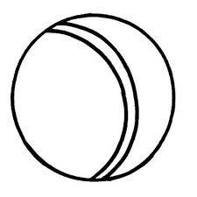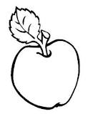

- Match!
Two green pears. Six black cats. One yellow lemon.

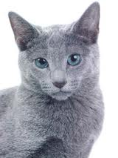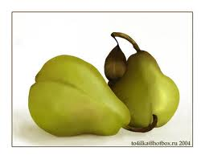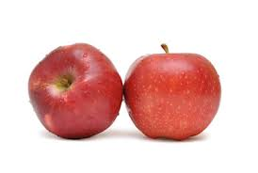

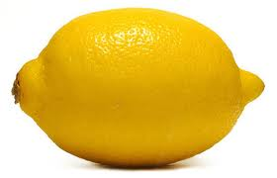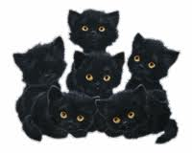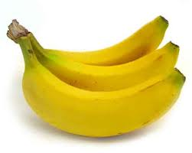

Two red apples. Three grey cats. Three yellow bananas.

- Who is Kate?
- Sam has got a yellow body, two green arms and two blue legs. Her head is pink.
Jane has got a yellow body, two green legs and two red arms. Her head is white.
Who is Kate?

______________ ______________ ______________

- Kate

- Crosswords.

1
8
2
3
4
5
6
7

3
7
5

1

The key: I like red.
6
2
8
4

- Little tables.
b | r | e | a | d
g | r | e | e | n
s | t | o | n | e
c | r | o | w | n
l | e | m | o | n
Хлеб Зеленый
Камень Корона
Лимон

- «Шерлок Холмс» (поиск словарных слов)

r | e | d | t | b | r | o | w | n | b
j | c | y | b | k | q | n | p | a | l
g | t | w | l | e | l | t | v | z | a
r | u | t | u | e | r | m | z | y | c
e | l | o | e | q | t | p | i | n | k
e | j | k | w | o | a | k | t | p | e
n | b | j | m | x | w | u | i | p | g
r | y | e | l | l | o | w | j | w | r
h | o | r | q | c | u | h | o | f | e
o | r | a | n | g | e | i | p | g | y
e | p | h | t | u | w | t | q | z | e
f | a | v | i | o | l | e | t | j | q

- “Happy warm”
(Закрасить кружки в заданном порядке)

- Rebuses.
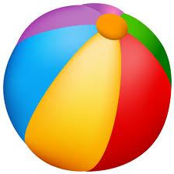 + 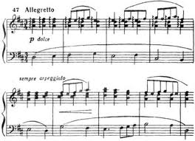 = ?
1 2 3 4 1 2 3 4

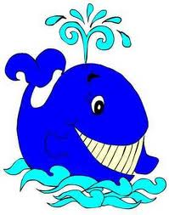,,, + ,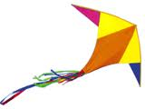= ?

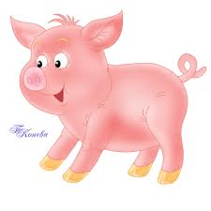, + = ?
1 2 3 4

,, + ,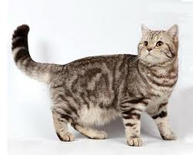 , + ,,,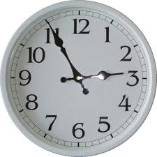= ?

- Merry painter. 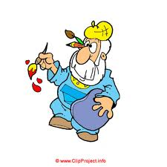
Make new colours and colour the picture.
Green & red | blue & yellow | Black& white | yellow & red | blue & red | red & white
1 | 2 | 3 | 4 | 5 | 6

1
4
6
5
3

2

