The American Flag.

The "Stars and Stripes" is a popular name for the red, white and blue flag of the United States. Another popular name is the "Star Spangled Banner". This is also the name of the National Anthem of the United States.

Every country has its own flag. In 1776 the thirteen colonies declared their independence from Great Britain. So the United States were born.

George Washington was a general of the American Army. He decided that the United States also needed a flag. There is a story that General George Washington asked Betsy Ross to make the flag. She used three colors: red, white, and blue. The red color was for courage, white was for liberty, and blue was for justice.

She sewed thirteen red and white stripes and thirteen white stars in a circle on a blue square. The thirteen stars and stripes stood for the number of states at the beginning of the United States. On June 14, 1777, the Congress confirmed this flag as the National Flag.

Later new states joined the United States. And in 1818 the Congress made another law about the flag. The thirteen stripes stayed the same, but for each new state there was a new star. Today there are fifty stars on the flag. Hawaii Island was the last star in 1959.
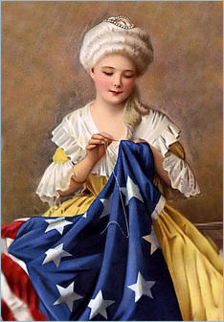
Betsy Ross.
