4th form Unit 2 Test yourself
- Look at the picture and mark the sentences below T(true) or F(false):
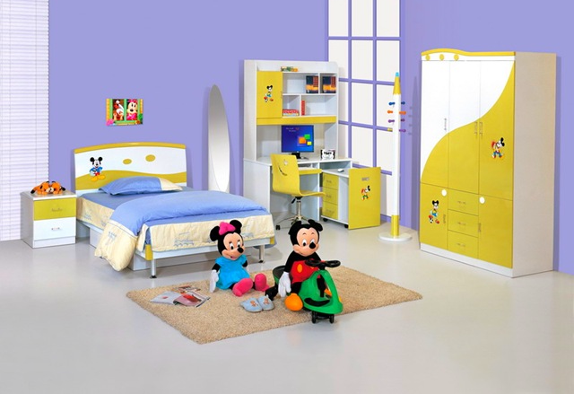
- It is a bedroom. ______
- It is not a kitchen._______
- There is a desk in the right corner. _____
- There are some shelves above the desk. _____
- There is a computer under the desk. ______
- There is no wardrobe in the room. ______
- You can see a nice lamp between the bed and the desk. _____
- They have got a clock on the wall. _____
- There are two pictures above the bed. _____
- There is a carpet on the floor. _____
- Fill in is or are:
- Behind the door there …. a green sofa.
- There … a clock on the shelf in the corner.
- There … a lot of pupils in the classroom.
- There … ten pencils and two pens in the pencil box.
- There … no fireplace in the living room.
- There … no windows in the pantry.

- Match the Russian and the English sentences:

- There is a big armchair at the table.  - There are no books on the shelves.  - There is a nice brown table in the middle of the room.  - There is a fireplace between the window and the sofa.  - There is no carpet in the left corner of the living room. | - Между окном и диваном есть камин.  - В середине комнаты красивый коричневый стол.  - У стола большое кресло.  - На полках нет книг.  - В левом углу гостиной нет ковра.

