Пелихова Вероника Вячеславовна

МБОУ гимназия №9 г.Коломна
Учитель английского языка

Lesson: “Britain. The country of mysteries, legends and traditions”

Урок обобщения и систематизации знаний, умений и навыков обучающихся. Он является завершающим этапом четвёртого раздела “The English world” в курсе изучения английского языка в 6-м классе (УМК “New Millennium English”, Деревянко Н.Н.).

Цели урока:
Учебный аспект: повторить и обобщить основной лексико-грамматический материал раздела, развивать и совершенствовать речевые и коммуникативные навыки обучающихся
Развивающий аспект: развитие мотивационной и эмоциональной сфер личности обучающихся, памяти и внимания
Воспитательный аспект: приобщении обучающихся к культуре, традициям и английским реалиям ,формирование положительного отношения к культуре народа страны изучаемого языка.
Познавательный аспект: познакомить обучающихся с героями английского фольклора, историей названий улиц Лондона.

План урока
1. Организационный момент.
2. Вступительное слово учителя.
3. Warming up- фонетическая/речевая зарядка в режиме “Teacher-Pupils”
4. Основной этап:
(индивидуальное соревнование)
*Find the word
*Right and wrong statements
*What is missing?
*Grammar race
*What can you tell about…?
(итог)
RELAXING-pause
(командное соревнование)
*Reciting
*Questions about England
*Spot the words
(итог)
5. ИТОГИ (заполнение карточки-достижений)
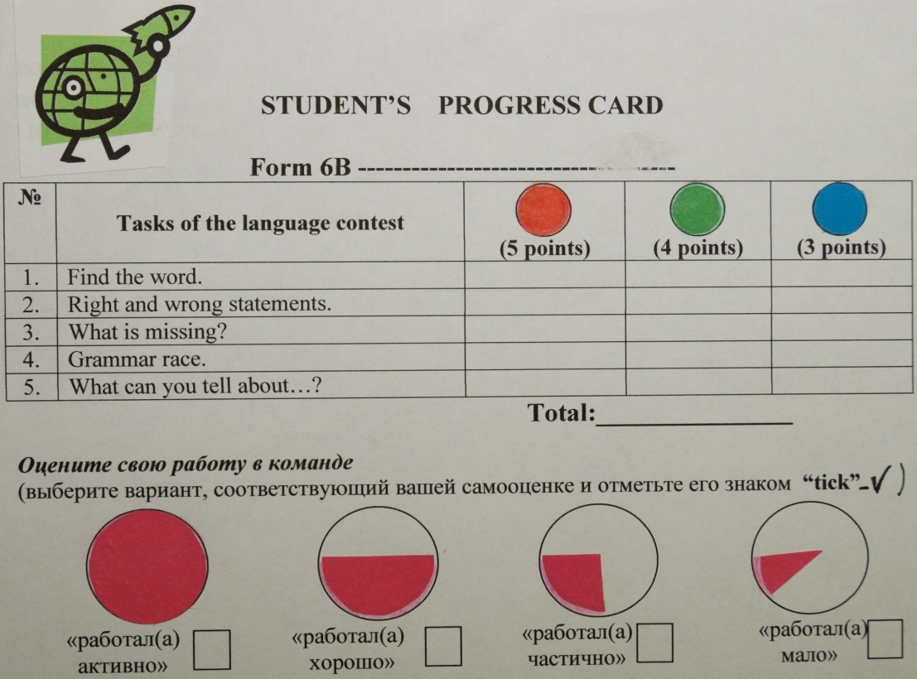

1. Организационный момент.
Hello to those who is as cheerful as a lark.
Hello to those who is as black as ink.
Hello to those who is as closed as an oyster.
Hello to the greatest chatterboxes.
Are you going to be as busy as a bee today? Take your seats, please.
2. Вступительное слово учителя.
Today we have an unusual lesson about Britain, the UK (the United Kingdom)-the country of mysteries, legends and traditions. We have a language contest (students’ contest and teams’contest). You’ll have a chance to do different tasks and get some points. Look at your desks! Can you see students’ progress card? Each of you should write the score after the task. Put “tick” in proper place of the table. In the end we’ll know the names of the winners and find out which team is the best
Look at the blackboard, please.
(На доске фразы “Feel friendly”, “Don’t lose your heart!”, “Don’t be scared of mistakes!” Are you ready? OK! Get down to business!
3. Warming up (фонетическая/речевая зарядка)
(На столах –лист с заданием для каждого)
Look at the words and repeat after me:
(слова повторяются хором за учителем)
The United Kingdom, England, Scotland, Wales, Northern Ireland, London, Edinburgh,
Cardiff, Belfast, a thistle, a rose, a shamrock, a daffodil, the Thames, the Avon,
Buckingham Palace, Baker Street, Big Ben, Loch Ness, bagpipes, kilts, the Eisteddfod,
Caernarvon Castle, the Giant’s Causeway, Bath, York,
the Roman Baths, Sally Lunn’s House and Museum, The Bath Boating Station,
The Museum of Costume, Bath Postal Museum, York Minster,
the Jorvik Viking Centre, the National Railway Museum.

I.T – Ps: Look at the words and name (за названные категории получает очки)
the parts of the UK- (Scotland, Wales, England, Northern Ireland)
the capitals-….
the symbols-…
the rivers in Britain-…
the places of interest-…
interesting facts-…

II. P: What do you know about Britain? Let’s see. Listen to me.
Agree or disagree with me. Am I right?
T-P1, P2, P3 (statements-agree/disagree)
T:1. The capital of Scotland is Edinburgh.+
P: I agree with you. The capital of Scotland is Edinburgh.
2. The symbol of Wales is daffodil.+
3. The Thames is a river in Northern Ireland.-(in England)
P: I disagree with you. The Thames is a river in England.
4. The Eisteddfod is a castle in Wales.- (competition of poets, writers and musicians )
5. The English wear kilts.-(the Scottish)
6. You can see the Giant’s Causeway in Northern Ireland.+
7. Loch Ness is a famous lake in England.-(Scotland)
8. Buckingham Palace is the home of the British Queen.+
9. Bath and York are cities in England.+
10. You can go on a river trip in York.-(in Bath)
11. Penny Black was the first museum in the world.-(stamp)
12. You can be a real Viking in York.+

III. T: You’ve read texts about different places of interest.
Do you remember any facts?
P1-P2 (Fill in the gaps)- выполняется самостоятельно, затем взаимопроверка (читают желающие по одному предложению
bell, fashion, castles, glass, museum, clock.

1. Wales is the country of princes and …castles
2. There is a museum…about Sherlock Holmes in Baker Street.
3. Big Ben is the name of the big bell…in the clock … tower.
4. In the Museum of Costume there is a library with books on the history of …fashion
5. You can see the famous stained glass…windows in York Minster

IV. T: Now we have a grammar race.(работа в парах Р1-Р2),
кто первый выполнил встаёт, демонстрируя готовность.
(Р1-читает слова с артиклем, Р2-читает слова без артикля)
The UK Scotland
England The Welsh (people)
London Baker Street
The English (people) Great Britain
The Thames The Atlantic ocean
The Avon
Bath
York

V. T: How many parts are there in the UK? What are they?
We’re going to have a trip around Britain.
P1-P2-P3-P4 (group-work) (Каждая группа получает конверт с карточками,
на которых написаны слова.
Задача составить по ключевым словам рассказ по теме “Scotland” (1-я гр.),
“Wales” (2-я гр.), “Northern Ireland” (3-я гр.)
(The capital of Scotland is Edinburgh. The symbol of Scotland is a thistle.
The population of Scotland is 5 million people. The Scottish live in Scotland.
The interesting facts are kilts and bagpipes. We can see Loch Ness in Scotland)

Карточка-достижений.
Подсчёт баллов по индивидуальной работе(самооценка)
T:How many points have you got? P:I’ve got 15points.
T:Who is the winner? The first place is for…
T: Now it’s high time to start team competition. Get into 2 teams, please
(деление класса на команды по 6 чел)
Результаты работы оценивается цветными фишками,
которые выставляются в кармашки табло.

I. T: Let’s imagine that we are at the Eisteddfod and going to take part
in a reciting competition.Will you recite the poems about Mrs Beeds.
(по 1 чел. от команды)

When Mrs Beeds came to Leeds
She bought some sweets.
When she came to Bath
She had a bath.
When she came to Cambridge
She ate a sandwich.
When she reached London
She saw a great Kingdom.
II.
(звон колокола Биг Бена)
T: Where are we now? Is it England? Yes, we are here.
What do you know about England? Let’s see.
(каждая команда получает набор карточек, из которых необходимо составить
3 вопроса для команды соперников. Оценивается правильность
составления вопроса и правильность ответов)

1. What is the capital of England?
2. What is the symbol of England?
3. What is the population of England?
4. Who lives in England?
5. What are the places of interest in England?
6. What would you like to do in England?

III.T: The English speak English. But there are British English and American English.
P1-P2-P3-P4-P5-P6 ( динамическое соревнование 2-х групп по 6 чел:
заполнение полей словами (кто быстрее по 1 чел к доске)

1-я группа закрывает слова Британского варианта англ.яз
2-я группа закрывает слова американского варианта англ.яз
(взаимопроверка по 1 представителю)
movie fall store
apartment vacation candy
autumn flat holiday
sweet film shop
IV.
T: London is the capital of England. What other English cities do you know?
They are Bath and York. There are a lot of places of interest there. Do you remember Mrs Beeds? She visited a lot of towns and cities. But what a pity! She is so absent-minded. She is happy to tell us about her travelling. Read her letter. Is it OK?

P1-P2 (чтение письма с ошибками, исправление ошибок)
Dear friends,
I like Britain. It is a wonderful country of mysteries, legends and traditions.
I was in England last summer. It was fantastic! I walked along Baker Street and took photos of Buckingham Palace in London. I ate famous buns in Sally Lunn’s House in York.
I saw an interesting collection of clothes in Bath Postal Museum. I watched water birds in the Bath Boating Station. I was on a Viking longship in Bath. I visited the National Railway Museum in York.
T: What is the result of the teams’ contest? (определение команды победительницы)
ИТОГИ:
*What was the most interesting task?
*What was the most difficult task for you?
*Define your part in the teams work (учащиеся оценивают свою работу в команде, делают соответствующую отметку в карточке достижений)
T: Dear friends! I’m very proud of you. A great job! Thank you very much to everybody.

