Технология критического мышления на уроке английского языка по теме: «Путешествие»
Технология: методика развития критического мышления (фазы «Вызов», «Реализация смысла» и «Рефлексия»)
Класс: 8
Общедидактическая цель: создать условия осознания и осмысление блока новой учебной информации, ее применение в новой учебной ситуации.
Задачи:
Общеобразовательные:
- способствовать развитию практического владения языком;
- создавать условия для формирования лексического навыков говорения;
- расширить кругозор по теме;
- реализовать межпредметные связи (география)
Познавательные:
- развитие лингво-культурной компетенции;
- активизация лексики и лексико-грамматических конструкций по теме.
Воспитательные:
- создать условия для формирования способности и критическому мышлению;
- воспитать умение внимательно слушать и слышать, уважать другое мнение;
- формировать потребности и способности к сотрудничеству и взаимопомощи при работе в паре или группе.
Развивающие:
- создать условия для развития исследовательских умений учащихся, способности к распределению внимания;
- развитие способности к переключению уровней мышления.
Оборудование урока:
- мультимедийная презентация к уроку;
- карточки с заданиями;
- книга чтения В.П.Кузовлев, Н.М. Лапа. Английский язык 8 класс для общеобразовательных учреждений.
- отрывок из фильма «Остров сокровищ»

Ход урока
1. Стадия вызова. ( Evocation)
T.-Good morning, students. I hope you are fine today. Now I see you are ready to start working.
- Please, look at our screen and lets read the quotation by St.Augustine [/seint o: / gastin]
«The world is the great book, of which they, who never stir [stə:] from home, read a page.»
- Rita, please, read it. Thank you. Let/s try to translate Nikita.
- What does the author mean by this?
St: People should travel if they want to know about the world.
- You are right.
T: So today we are going to talk about travelling, tourism and travel destinations.
T: As you see the theme of our lesson is
«The world of travelling»
T: By the way, do you like travelling?
And why do people travel?
T: Let/s take the word «Travelling» and give some associations to this word.
T: Explain why you think so!
(you may use card №1)

Travelling
Transport
Sights
Travel
habits
activities
accommodation
impression

Take your card and go to the board.
T: Why do you think so?
St:
T: Thank you. I see you have different associations to this word.
2. Стадия осмысления: «Реализация смысла».
(Realization of meaning)
T: When you are talking about travelling + What authors do you remember?
- And what adventure stories have you read ?
St: «Around the world in 80 Days» by Jules Verne
«Treasure Island» by Robert Louis Stevenson
T: Thank you. And now students we/ll watch an extract of a film. Try to guess the film.
T: Did you guess what the film is?
St: «Treasure island»
T: Do you know the author of the book «Treasure island», Robert Stevenson travelled abroad many times.
T: I want to offer you to read a passage from the gook about one of Stevenson/s trip. Open our Readers at p 31.
First, look through the text and find the geographical names in the passage and math them with transcriptions.
I/ll give you 3 minutes.
Our time is over. Read them. Thank you.
T: Now Start reading our passage and then answer the question: What was Stevenson/s travel destination?
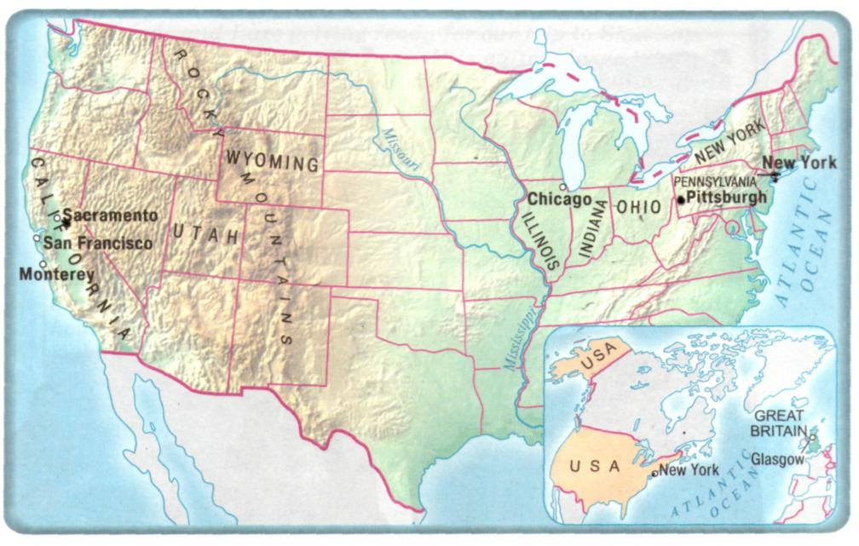
T: Look at the map. We are going to travel with Robert Stevenson according to his route. New words will help you.
T: Use cart 2. Put sentences in order. Start with the sentence 1
I/ll give you 5 minutes.
We start our voyage from Glasgow for New York by steamship.
We go through Ohio, Indiana, and Illinois.
We run to the ferry that would carry us to San Francisco.
In New York we get into the train and go to Pennsylvania.
At last we are in California.
Then the train reaches Pittsburgh.
At Chicago we change the train.
The train reaches Wyoming and the Rocky Mountains.
The train stops at the city of Sacramento.
And then we find Monterey.
T: Now our journey across America is over. And we are in Russia in Kamensk

3.Рефлексия (фаза суммирования и систематизации новой информации)
T: To sum up I offer you to make a poem about travelling. It, consists of 5 lines.
Cart №3. For example.
А роеm:
A general word is Travelling
Two adjectives on the topic - exiting, romantic
Three verbs – to enjoy, to relax, to sunbathe
The main idea of your роem (4 words) -
The best way to escape from boredom!
A synonym of general word - journey

4. Homework.

T: At home I want you to write a letter to your foreing friend about a place and how you spent your time there.
T: Our time is over. And I like your work at the lesson and give you only exellent and good marks. You have worked hard. Thank you for your good work.

