Викторина по теме

«Do you know Great Britain?»

Составитель: Аржакова Наталья Нохавна

учитель английского языка
МОБУ СОШ №21 г.Якутска
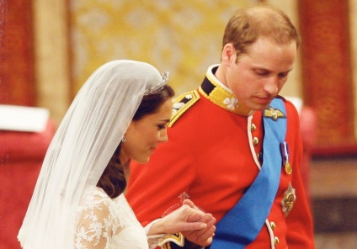 | The Royal Wedding. Prince William and K… … (2 points)
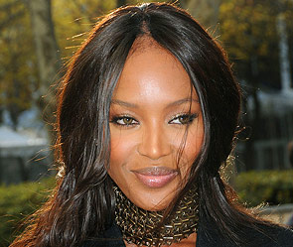 | This celebrity is from England, but now she lives in Moscow.  N… … (2 points)
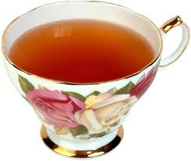 | An old tradition of Englishmen with a proper teapot.  A… … (2 points)
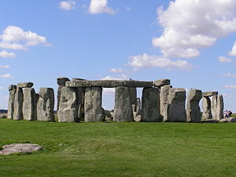 | It is an ancient stone circle on Salisbury Plain.  S… (3 points)
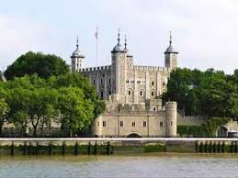 | The castle William the Conqueror built after he defeated King Harold at the Battle of Hastings.  The T… … … (3 points)
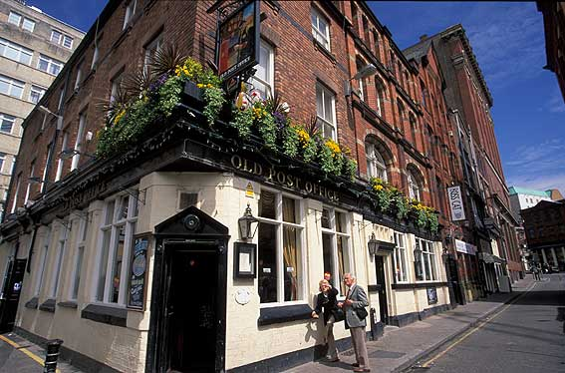 | This city has soul-and music. If you love Beatles and their music, come here to explore!  L… (3 points)
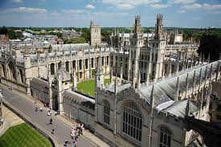 | Famous for its university, wonderful college buildings, Alice in Wonderland and Tolkien. O… (4 points)
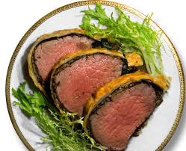 | It was the main dish for an old English Christmas dinner. Beef was covered with dough and baked in an oven.  B… … (4 points)
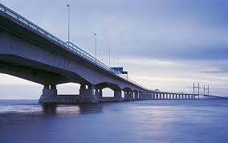 | England’s longest river. It goes from Shropshire in the north all the way down to Bristol in the south.  The River S… (3 points)
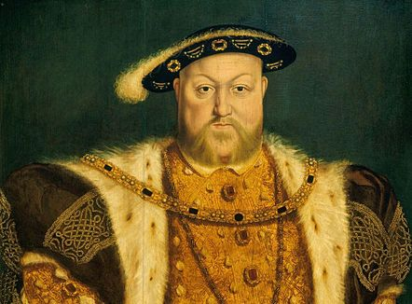 | The marriage that changed England several centuries ago.  H… … and A… … (5 points)
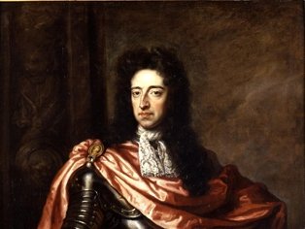 | Who was the last king of England?  W… … … …. (5 points)
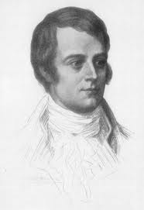 | Scotland’s national bard.  R … … (3 points)
Your question
(4 – 5 points)

