Тест 1. «Узнай композитора»
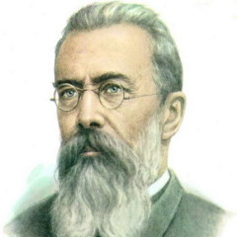________________________________________________________________________________
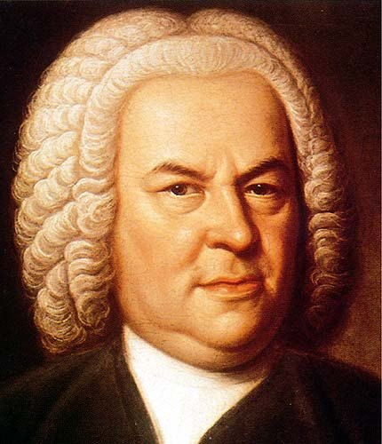_________________________________________________________________________________
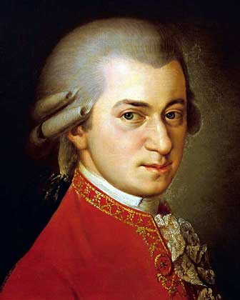_________________________________________________________________________________

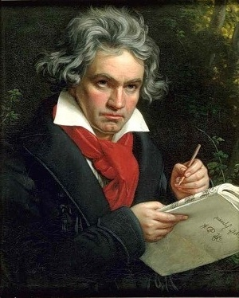_________________________________________________________________________________

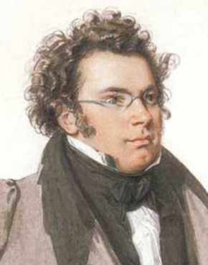_________________________________________________________________________________

Тест 2. «Узнай композитора»


