Date: 16.01.15
The theme: The rules of sport.
The aims:
- educational: to rise students’ knowledge about rules of sport, to know about modal verb “ can/ can’t”
- practical : to work in small groups, to do exercises, to write mini –dictation, to learn new words.
- cultural: to interest students in learning English.
Visual aids : cards, pictures, tests.
The course of the lesson:
I Orgmoment: Greetings.
II Phonetic drills: p: 91 “Dream park” sing the song
III New theme:
- Divide students into four groups, one of them is a leader.
- Brainstorming: abkesbtlla
ntnsie
owbilng
otbfallo
What is the theme of the lesson?
- Vocabulary:
1 catch -c
2 kick -f
3 carry-b
4 head-a
5 throw-d
6 hit-g
7 roll-e
8 hold-h

- Ex: 1 a p: 44 Listen. Match the verbs with the pictures.
- Ex: 1 b p: 44 Listen and check.
- Presentation: Listen and read. Think about your answers.
Rules of sport:
  - Basketball
a)
b)
c)
  - Bowling
a)
b)
c)
  - Tennis
a)
b)
c)
4. Football
a)
b
c)
7. Grammar Spot: Can/ can’t
8. Make three questions with the beginig: can you…?
9. Ex: 3 c p: 45 Make sentences with You can… or You can’t …
  - Bowling – You can’t throw the ball.
  - Tennis- You can’t roll the ball.
  - Basketball- You can’t roll the ball.
  - Football – You can head the ball
  - Bowling – You can’t kick the ball.
  - Tennis- You can’t catch the ball.
10. Answer the questions:
Teacher: Listen to me. I’ll describe you a sport.
- Eleven people play this game, they use black and white ball to play (football)
- You need a skate for it. (skateboarding)
- You must come to a pool or to a river to go in for it (swimming)
- Strong men like this sport. They wear white kimonoes. (judo)
- These are two types of athletics (running/jumping)
- You need a big orange ball and a basket with a net to play this game (basketball)
- You need a white ball to play this game. You play with your hands and arms (volleyball)
- Girls usually like this sport (gymnastics)
- You need two rockets, a white ball and a net.(tennis)

11. My English file: students write rules of sport or a game of their choice. They should use can or can’t.
- Conclusion: Write what sport can we do with:
- Balls – football, tennis, polo etc.
- Skates- figure skating, ice hockey, ice running etc.
- Rackets- badminton, tennis, ping- pong etc.
- Water- water polo, water skiing, swimming etc.
- Horses- polo, horse racing, jumping etc.

Communal state organization
school-gymnasium № 1 by name M.Gorky

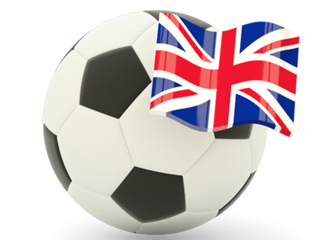
Demonstrative lesson :

“Rules of sport”

Form : 6 “A”
Teacher: L. Rajapova

приложение
- Vocabulary:
1 catch -
2 kick -
3 carry-
4 head-
5 throw-
6 hit-
7 roll-
- hold-
- Rules of sport:
  - Basketball
a)
b)
c)
  - Bowling
a)
b)
c)

  - Tennis
a)
b)
c)

  - Football
a)
b
c)
3. Ex: 3 c p: 45 Make sentences with You can… or You can’t …
  - Bowling – You can’t …
  - Tennis- You can’t …
  - Basketball- You can’t…
  - Football – You can …
  - Bowling – You can’t …
  - Tennis- You can’t …

4 What can we do with
- Balls –
- Skates-
- Rackets-
- Water-
- Horses-

