МБОУ Лицей № 7

г. Саяногорска Республика Хакасия

Конспект урока по английскому языку:
«Past Progressive»

Выполнила: Черноусова Олеся Ярославовна,
учитель иностранных языков

г. Саяногорск, 2014

Past Progressive (Past Continuous)-Прошедшее Продолженное Время
Используется для того, чтобы описать какое-либо действие, которое происходило в определённое время в прошлом.
Образуется при помощи: was/ were+V_{ing}
Present Progressive
(+) | подлежащее | Was/were + V_{ing} | I was watching TV.  You were watching TV.
(-) | подлежащее | Was/were not + V_{ing} | He was not watching TV.  They were not watching TV.
(?) | Was/Were+подлежащее | V_{ing} | Was she watching TV?

Was употребляется с I, she, he, it
Were употребляется с you, we, they
Examples:
Fred was playing at the beach at 5 o’clock yesterday.
We were talking when mother came in.
While I was working, Tom was cooking.

Complete the following sentences:
- At eight o’clock yesterday I …
- When my granny called I …
- My mother was watching TV yesterday evening while my father …
- When the clock struck midnight my family …
- While I was doing my homework yesterday my friends …

I … at 3 o‘clock yesterday.
My mother … at 3 o’clock yesterday.
My father … at 3 o’clock yesterday.
My grandparents … at 3 o’clock yesterday.
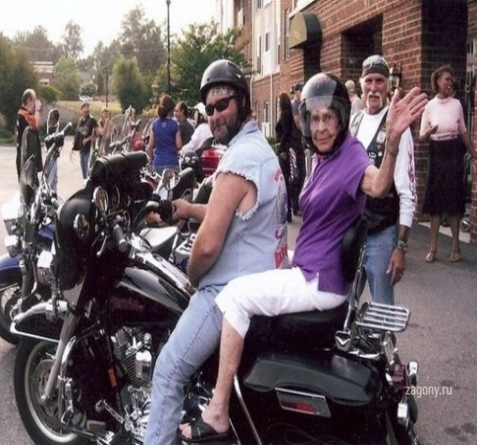
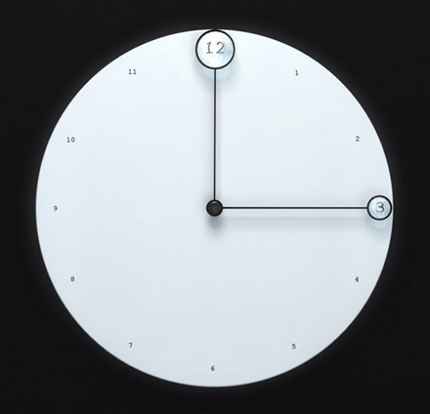
Was/ were + V _{ing}

My cats … at 3 o’clock yesterday.

My sister … at 3 o’clock yesterday.

