Отчёт об открытом уроке
английского языка,
проведённого в 5 и 6 классах
Сальниковой Л.Н. и Щукиной Л.А.
для учителей иностранного языка северного региона Московской области

Класс: 5 и 6
Тема: Making a Project
Дата проведения: 17.04.2014
Цель урока: выработка УУД в области устной и письменной речи по теме
Задачи урока: 1) образовательные:
- повторение пройденного лексического материала
- повторение пройденного грамматического материала
- актуализировать имеющиеся знания учащихся по теме
- развивать навыки неподготовленной речи
2) воспитывающие:
- расширять кругозор
- прививать любовь и интерес к иностранному языку
- воспитывать умение работать в разновозрастных группах
3) развивающие:
- продолжать развивать умение общаться на иностранном языке
- строить высказывания самостоятельно
- развивать воображение и внимание учащихся
Тип урока: комбинированный
Виды речевой деятельности: говорение, чтение, аудирование, письменная речь
Образовательные технологии: технология проектного обучения, групповая, технология сотрудничества, технология коммуникативного обучения, здоровьесберегающая технология, технология фронтального обучения, компьютерная технология
Оснащение урока: интерактивная доска, распечатки заданий для контроля пройденного ранее лексического материала, песочные часы (1 минута), CD-Rom Round Up 3, клей, фломастеры, ножницы, flashcards

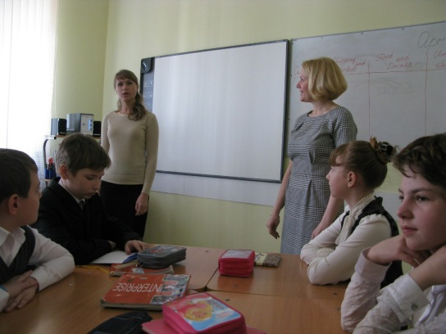
План урока
Ход урока:

- Организационный момент:
- беседа учителей с учащимися на английском языке
- вопросы учителей учащимся о готовности к работе
- установление контакта учителей с учащимися

L.N.:
Hello! Nice to meet you! Take your seats! How are you?
Today you are going to have a very unusual lesson. Two teachers will work with you: Larisa Anatolevna and me, Lyubov Nickolaevna.
Don`t forget about our guests. Say hello to them. Don`t be afraid. They are friendly.
And let`s start our lesson.

- Аудирование.
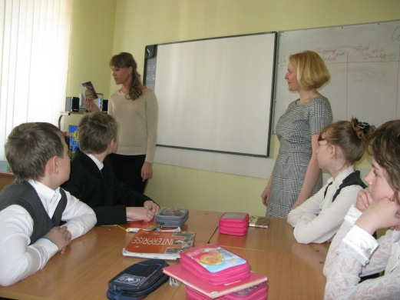
L.N.:
Look at L.A.!
She`s very happy today. Because yesterday she received a beautiful postcard from her English-speaking pen-friend Lily. And just now she`s going to read her letter for us.
Let`s listen.

L.A.:
Hi Larisa!
Greetings from Milan! I am having a great time here. The city is wonderful. I am here with my mum and we are staying at a hotel near the centre. Right now we are having breakfast. You know how much I love pasta. After the breakfast we are going on a tour around the city. I am going to visit an ancient cathedral and photograph it. After the sightseeing I am going shopping and my mum is going to go to the mountains. Italy is famous for designer clothes and there is a huge shopping mall in Milan. I want to buy a new dress for my birthday party. I am so excited! I can’t wait.
See you soon,
Lily

And now will you tell me please:
1) In what country is my friend?
2) Is she alone there?
3) Where is she going after breakfast?
4) What does she want to buy?

Ok, thank you, now I see that you are very attentive.

3. Объявление цели урока и деление на группы.
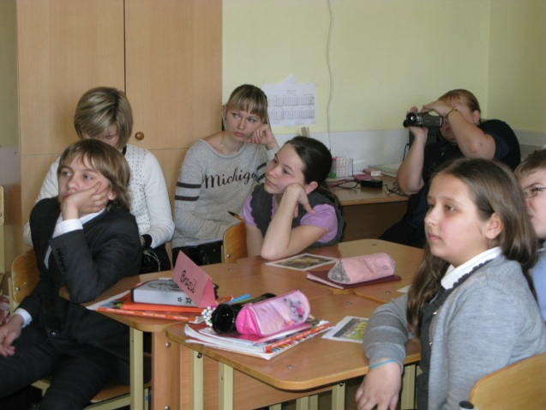
L.N.:
So, I suppose you can understand that today you`re going to write a postcard.
But to make our lesson & our work more interesting, let`s be divided into 3 groups: Germany, France & Brazil. Come to my place, choose a card & try to find your group.

4. Повторение пройденного лексического материала.
L.A.:
So imagine you are abroad, in France, in Germany and in Brazil. Let’s discuss what we will do there. (Children`s answers)
So, if we travel to another country we try local food, visit interesting places, buy souvenirs and clothes. We also mind the weather.
And you have a number of words on your desks, so the task is to use these words and fill in the table: on the go, shopping and markets, food and drinks, climate and weather.

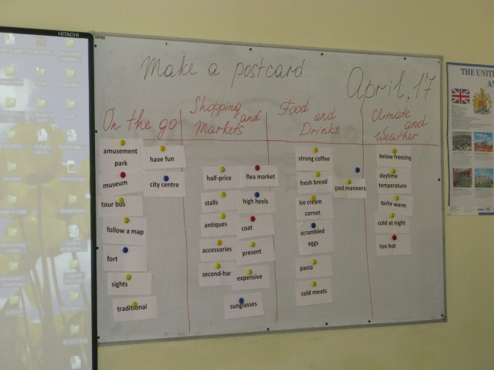
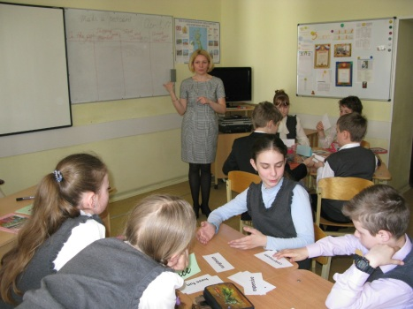
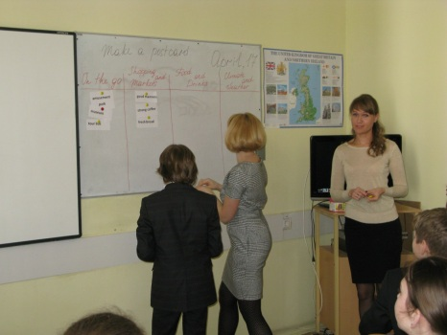
WORDS: have a great time, coach, city centre, flea market, sights, fort, mountain, museum, present, half-price, expensive, sunglasses, coat, second-hand, antiques, crafts, accessories, amusement park, have fun, food court, snack, ice cream cornet, hot dog, fried insects, stalls, get lost, follow a map, pottery, traditional, scrambled eggs, “fry-up”, cold meats, pasta, fresh bread, strong coffee, good manners, quite warm, too hot, daytime temperature, cold at night, drop, below freezing, characterize, high heels, tour bus, watch a parade.

5. Повторение пройденного грамматического материала.
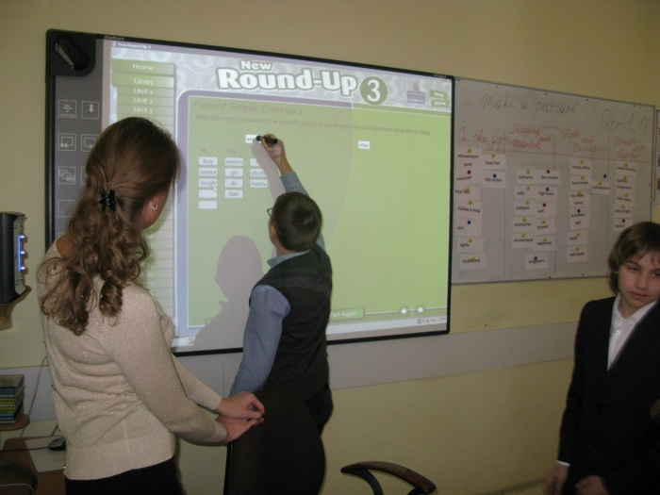
L.N.:
You can see a lot of different words. They can help you to write a postcard.
But let`s speak about tenses just now. What tenses should we use to write a letter? (Present Simple & Present Continuous)
Let`s do some exercises using our interactive board.
Round-up 3
- Unit 7- ex.2 & GAME
- Unit 8 ex. 2
6. Видео.
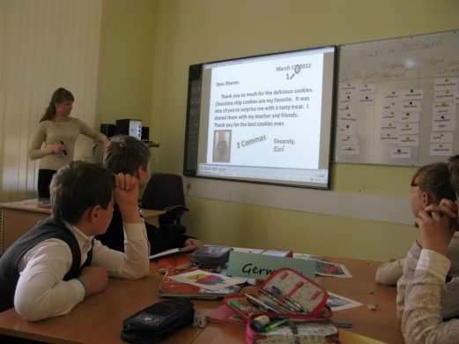
L.N.:
You have got a lot of information for writing a letter, but let`s revise the rules of writing a postcard. Watch a video.

http://www.youtube.com/watch?v=AOdwHvtOmic

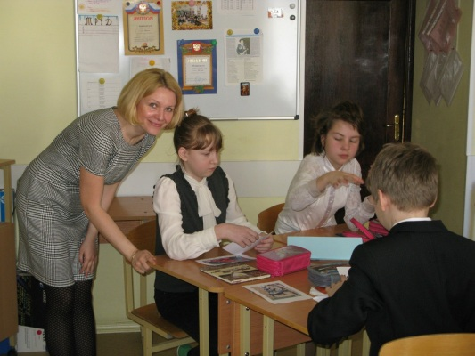

7. Проект.
Making a project and presentation of a postcard.
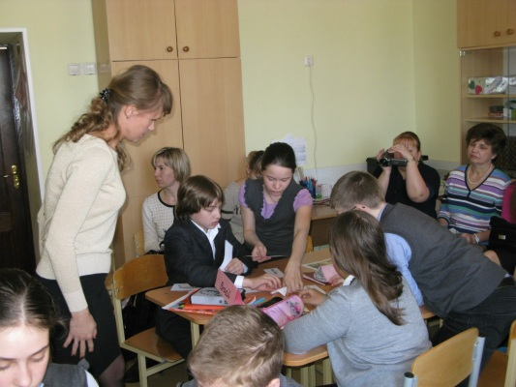

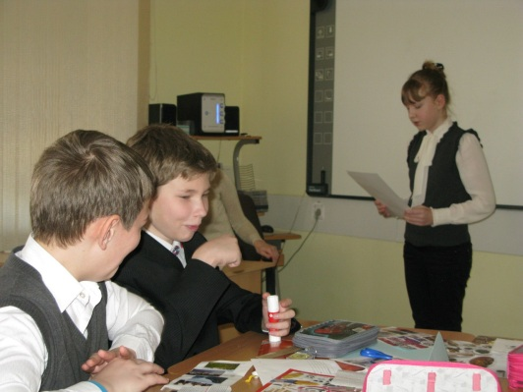

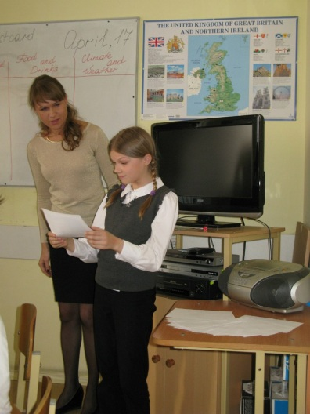
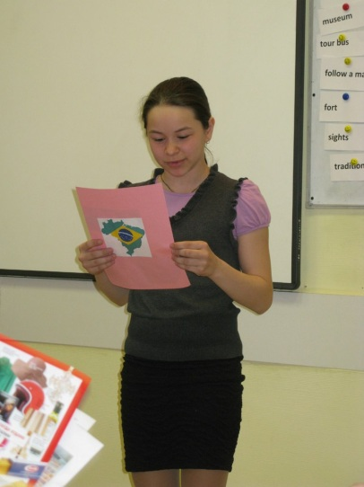

8. Домашнее задание.

Prepare a postcard from any country you wish.

9. Подведение итогов урока.

English teachers:
Our English lesson is finishing. Did you like it? Was our lesson interesting?
Thank you for your work. Well done. The lesson is over. Goodbye.

