**Svetlana Ryazantseva**, teacher of English

Municipal secondary school “Dmitrov Gymnasium “Logos”

Open class

“Exams: how to cope with stress”

Form 9; Level Intermediate

Date: April, 17, 2014

**Goal**: to discuss the good and bad points of taking exams and offer some ways to cope with the exam stress. Write a letter to a friend, offering some advice on releaving exam stress

**Objectives:**

1. Brainstorm for ideas about exams
2. Give opinions on good and bad sides of exams
3. Skim text for main points of information; analyse information to give opinions
4. Perform a dispute for/against exams
5. Roleplay a dialogue making suggestions how to relieve exam stress
6. Learn how to persuade / make excuses
7. To encourage the students to use the vocabulary on the topic of “Exams”
8. To encourage the students to use phrases, expressing the opinion like “I believe, In my opinion, etc”
9. To practice using linkers such as “moreover, as well as, on the other hand, etc.”
10. To practice listening and speaking

**Technologies used in the course of a lesson:**

1. Communicative technology
2. Group work technology
3. ITC technology

**Exam strategies:** letter writing; communication activity – a dialogue; reading for specific information

**Language skills**, developed throughout the lesson: speaking, listening, reading, writing

**Equipment**: projector, whiteboard (or a screen), computer with an access to the Internet, presentation, handouts, coursebooks **Enterprise IV*, coursebook p125, by V.Evans /J. Dooley; Express Publishing,* Get on Track to FCE*. Coursebook pp……… by Jane Allemano; Longman ,*Blockbuster 4*. Student’s book, pp52-53.By J. Dooley &V. Evans. Express Publishing,* Practice Exam Papers for the RNE *p99, by O.Afanasyeva, V.Evans, V. Kopylova. Express Publishing/Prosveshcheniye* ( you have got all necessary material in the Supplement)**

**Lesson plan**

1. Greetings
2. Warming-up activity (introducing the topic)
3. 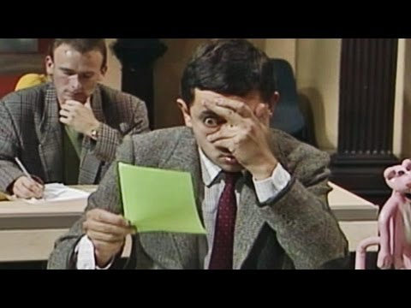Watch a 2 min video “Mr. Bean takes an exam”
4. Ask the students to comment on the video (possible questions: What general idea have you got concerning exams?

How does the character feel?

What’s your opinion: did he perform well in the exam? Why? )

1. **Main part Slide 1 - Slide 2**
2. (Introducing the objectives) Well, you can guess now what problematic issue we are going to discuss now. (students’ answers)

(to sum it up): **to discuss the advantages and disadvantages of the exams; to offer some ways to cope with stress and prepare to write a letter giving advice.**

1. Let’s start with your own experience **Slide 3**

– Have you ever taken an exam? When?

* Did you like the experience? Why?
* Should we ban the exams? Why?

- So, as you’ve said exams might have their positive sides as well. (together with negative ones)

1. **Reading, speculating (Slide 4)**

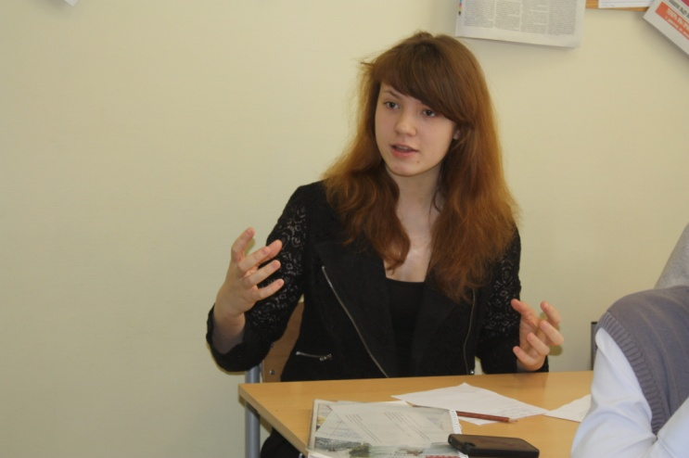***Enterprise IV, coursebook p125, by V.Evans /J. Dooley; Express Publishing***

- Read the following comments made by students and decide whether each is for or against taking exams

(students then all read and discuss the comments and make their decisions)

- Let’s see what we’ve got – how many points for and how many against**(Slide 5).**So, we’ve got 4 comments “for” and 4 comments “against”. A draw! (students all get a printed worksheet with the result of the previous activity – **supplement 1**)

1. **Brainstorming for the ideas about exams.**

* Rearrange the desks so that we can work in groups. Group 1 think of some other points **against exams** whereas Group 2 consider some extra points **in favour of exams**. You’ve got 2 minutes. (students discuss in groups and make notes in their copybooks) Don’t forget to use the following phrases to express your agreeing or disagreeing. **(Slide 6)** 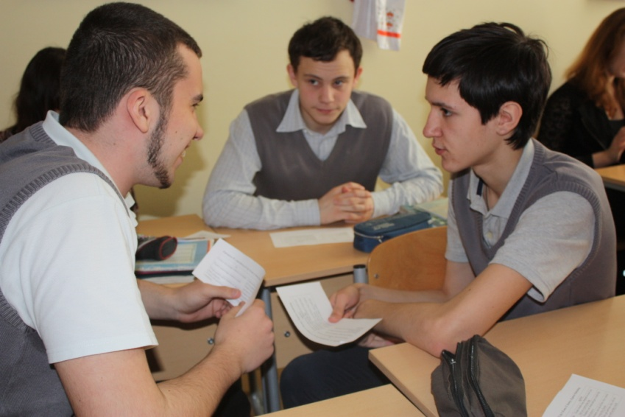

1. **Dispute. Giving opinions on good and bad sides on the exams.**

* 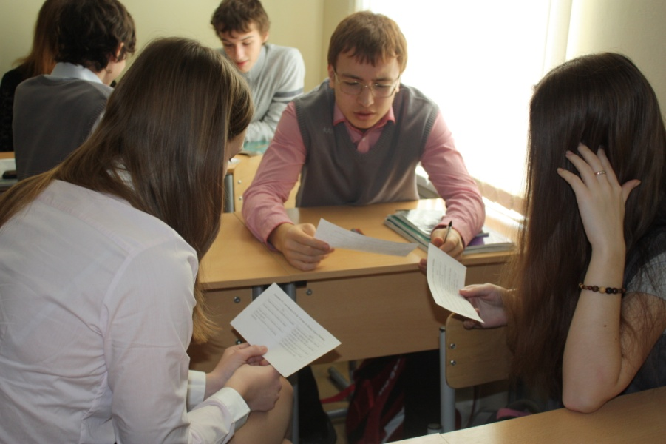Now, when you’ve finished, you are going to persuade the other group to accept your point of view. Be polite (use the phrases from **Slide 6**). Again, you’ve got 2 minutes. (students perform their arguments in turn, using the appropriate expressions of agreeing and disagreeing)

1. (after the discussion is over) - Well, you see, there are so many points both in favour and against exams, so let’s agree to differ! Exams are inevitable. We can’t avoid taking exams! So, what can be done about the whole situation? - Nothing, but help find the ways to reduce stress and pass the exams successfully!
2. **Reading. Skim texts for main points of information; analyse information to give opinions**. (**supplement 2**) **Slide 7** – a picture of your student

***Get on Track* to *FCE. Coursebook pp……… by Jane Allemano; Longman***

(Handout with the texts are distributed among students .)

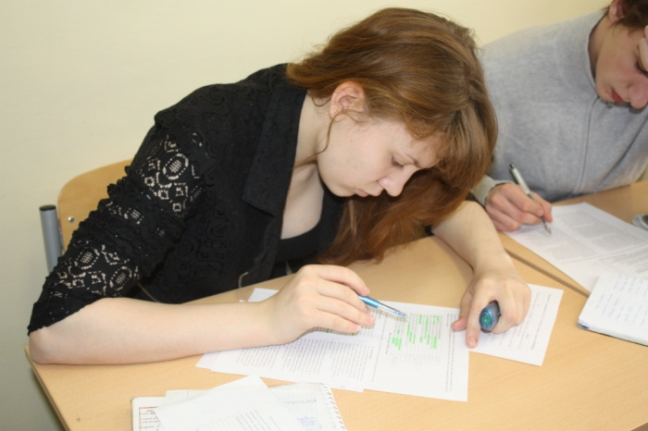 - You are going to read how some students cope with the exams. Read carefully since you have to justify your choice. Underline or highlight the clues in the texts. Complete the task individually. (2-3 min)

* After you’ve finished, check the answers in your group. Justify your answers.
* Now, make notes on ways to cope with the exams, offered by these students. We might need them later. (students make notes in their copybooks **if they have time**).

1. **Communication. Reading and filling the gaps.(Slide 8)**

***Blockbuster 4.Student’s book, pp52-53.By J. Dooley &V. Evans. Express Publishing.***

* Look at the dialogue between two students. Think of the possible replies to fill in the gaps. Work in pairs. (students offer the variants, discuss)
* Now, let’s listen and check (Let’s see the correct answers). **Slide 9**
* - OK, you’ve got the model. Shall we read this aloud? Beautifully? (2 most gifted students read aloud the dialogue, or the ones who enjoy doing it) 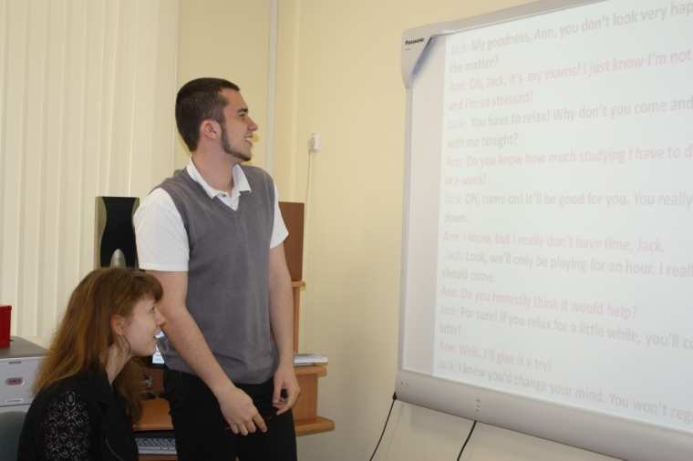

1. **Roleplay a dialogue making suggestions how to relieve exam stress**

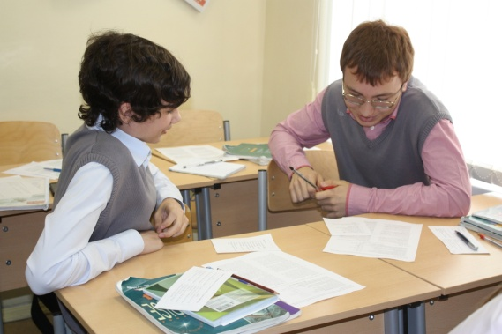 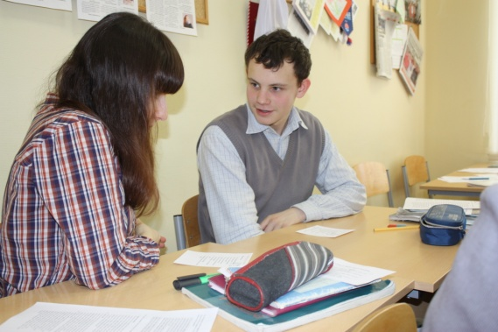

* Use the tips from some youth magazine **(supplement 3)** and the plan on the whiteboard **(Slide 10)**  to make up a similar dialogue. Work in pairs first, then you’ll act it out in front of the class. Be polite and use the phrases ( from the **slide 10**)to persuade, to reject an offer, to accept an offer. (students work in pairs, making up a dialogue). After they’ve finished, some pairs perform in front of the class 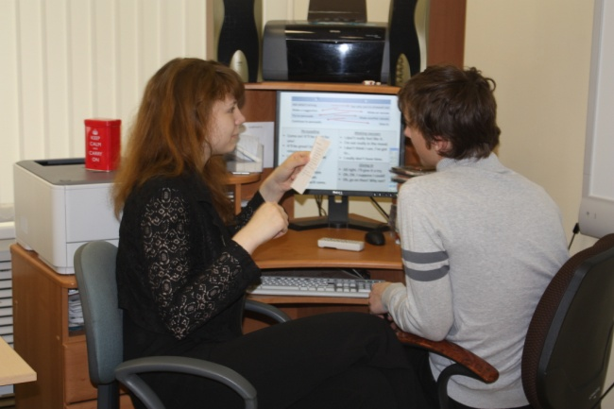

1. Summing-up. Feedback. To sum it up, you’ve discussed good and bad points of sitting exams, read about and offered different ways of overcoming the exam stress, you’ve also made up and poleplayed a dialogue on offering ways to reduce stress. Now you are better equipped to fight your exam stress if there is any.
2. Home assignment. Write a letter to your friend concerning exams and answer his questions. **Slide 11**

***Practice Exam Papers for the RNE p99, by O.Afanasyeva, V.Evans, V. Kopylova. Express Publishing/Prosveshcheniye***

**You have received a letter from your English-speaking pen friend who writes:**

**…*Well, my exams start next week and I’m feeling a little stressed even though I studied hard. How often do you have exams in your school? Do you like taking exams? How do you cope with the pressure?***

**Write a letter to Jack. In your letter answer his 3 questions.** **Write 100-120 words. Remember the rules of letter writing.**

(If there is some time left the letter is written in class.)

Good-bye! (**Slide 12)**

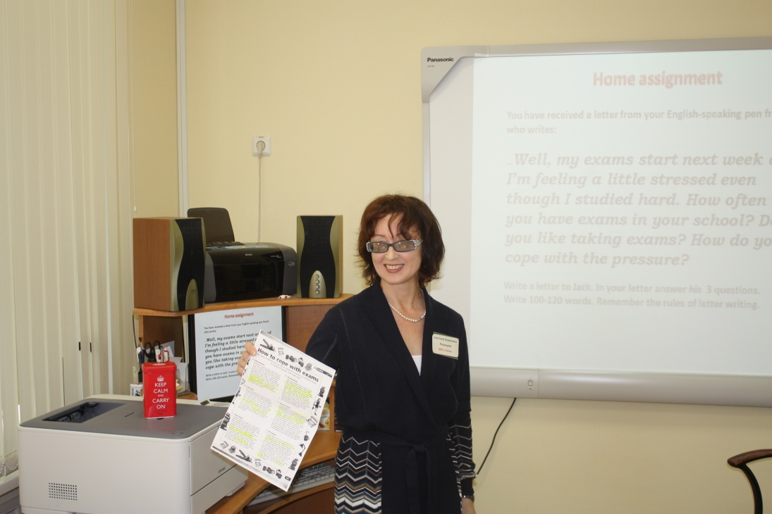

**Supplement 1**

***Enterprise IV, coursebook p125, by V.Evans /J. Dooley; Express Publishing***

|  |  |
| --- | --- |
| for | against |
| Exams encourage students to try harder | Exam results may depend on how you feel on a particular day |
| Exams encourage students to study | Students can cheat and get a mark they don’t deserve |
| Exam grades give students an idea of their progress | If students run out of time, they cannot show what they know |
| Exams are quickest way of testing students | If students get nervous, they will not perform as well as they could. |

***Enterprise IV, coursebook p125, by V.Evans /J. Dooley; Express Publishing***

|  |  |
| --- | --- |
| for | against |
| Exams encourage students to try harder | Exam results may depend on how you feel on a particular day |
| Exams encourage students to study | Students can cheat and get a mark they don’t deserve |
| Exam grades give students an idea of their progress | If students run out of time, they cannot show what they know |
| Exams are quickest way of testing students | If students get nervous, they will not perform as well as they could. |

***Enterprise IV, coursebook p125, by V.Evans /J. Dooley; Express Publishing***

|  |  |
| --- | --- |
| for | against |
| Exams encourage students to try harder | Exam results may depend on how you feel on a particular day |
| Exams encourage students to study | Students can cheat and get a mark they don’t deserve |
| Exam grades give students an idea of their progress | If students run out of time, they cannot show what they know |
| Exams are quickest way of testing students | If students get nervous, they will not perform as well as they could. |

**Supplement 2. Get on track to FCE.  *Coursebook p by Jane Allemano; Longman***

You are going to read a magazine article in which six students say how they cope with exams. For questions 1-14, choose from the people A-F. The people may be chosen more than once. There is an example at the beginning (0).

Which of the students

|  |  |  |
| --- | --- | --- |
| think you should keep a sense of humour? | 0 | E |
| discusses his/her worries with more experienced people? | 1 |  |
| stops and thinks before answering a question in the exam? | 2 |  |
| likes to be with people who have a positive attitude? | 3 |  |
| takes short breaks while he/she is revising? | 4 |  |
| thinks it is important to continue with a social life? | 5 |  | 6 |  |
| relaxes with music? | 7 |  |
| has not always done as well as he/she could in exams? | 8 |  |
| finds that coffee makes him/her feel more anxious? | 9 |  |
| believes that lots of physical activity is good during exams? | 10 |  |
| finds that other students in the exam room make him/her nervous? | 11 |  |
| believes that a lot of studying the night before is not helpful? | 12 |  | 13 |  |
| thinks that the time for revision always seems too short? | 14 |  |

**How to cope with exams**

*For many students, the run-up to important exams is a stressful time. Six students explain how they cope.*

1. **Kelly Marsden**.

Revising for the exams can be really tiring, so I try to stay alert by drinking cups of coffee while I’m studying. But the most important thing for me is to make sure I sleep well the night before the exam. I need at least eight hours a night to feel really awake the next day. Before I go to sleep, I put on a CD of my favourite singer, or read a book or magazine – nothing to do with the exam. It really wouldn’t help if I stayed up late studying because I would be too tired the next day to do my best.

1. **John Nott**

For me the best way to stop on top of things during exams is not to worry too much and to take time off from revision. Some people give up everything to spend their time studying, but I don’t actually think this helps you to do any better. I still meet up with my friends while exams are on. As well as that, I do a lot of exercise and I make sure I have a good work-out the night before an exam. I just know that my brain will function better if I feel in good shape.

1. **Alina Taylor**

I tend to panic in exams, so I have learnt that the best way to cope is to watch the time carefully throughout the exam. I plan how much time I will need for each question, and keep an eye on the clock to see how I am doing. I never tackle a question until I have thought about it, and made some rough notes on the answer. I try hard to ignore all those people around me who are writing really fast, as if they were crazy! They really put me off. When I see them, I think, ’It’s time I started writing too!’ and that’s when I start to panic.

1. **Richard Brook**

I get very stressed about exams a long time before they happen, and I have always wished I had more time to stud.In the past, I have found that I got lower marks than I could have got because I spent time worrying, not studying. So now, I talk things over with my parents and teachers. They often give very good advice, as they have been through it all before, and it helps to get all my anxieties into the open. I’d rather do this than waste a lot of valuable revision time worrying about everything.

1. **Helena Davis**

During exams, I avoid all those negative people who are completely stressed out and wish they had done more work. The night before an exam, I go out with my friends – I don’t believe in last-minute revision. We usually go for walk, or go round to someone’s house, order a pizza and watch a good video, preferably a comedy. It’s important to laugh a lot, and see the funny side of things when there is so much hard work to do the next day. When I go to bed, I simply glance through my notes one more time, and this helps me to feel ready for anything the next day!

1. **Bill Parson**

I know that I can only concentrate for a limited time, so I stop every hour or so for 10 minutes during my revision sessions. Even if I was the world’s greatest genius, I would start getting tired after an hour or so. I may go for a walk around the block to clear my head, or just sit and think about something else to take my mind off the exams. After that, it’s much easier to go back to my books. I think it’s also important to avoid drinking lots of strong coffee, because it tends to increase my anxiety, so I drink lots of fruit juice or mineral water.

**Supplement 3 Blockbuster 4*. Student’s book, pp52-53.By J. Dooley &V. Evans. Express Publishing***

**Suffering from stress?**

***Why don’t you…***

1. Do a yoga/aerobics class
2. Play a team sport
3. Go for a walk/go jogging
4. Watch a comedy
5. Tidy up your desk/room
6. Listen to some music
7. Meet up with your friends and talk it through
8. Do sth daring – e.g. a bungee jump
9. Take a long, hot bath
10. Imagine yourself on a hot, sandy beach!

****Suffering from stress?**

***Why don’t you…***

1. Do a yoga/aerobics class
2. Play a team sport
3. Go for a walk/go jogging
4. Watch a comedy
5. Tidy up your desk/room
6. Listen to some music
7. Meet up with your friends and talk it through
8. Do sth daring – e.g. a bungee jump
9. Take a long, hot bath
10. Imagine yourself on a hot, sandy beach!******

**Suffering from stress?**

***Why don’t you…***

1. Do a yoga/aerobics class
2. Play a team sport
3. Go for a walk/go jogging
4. Watch a comedy
5. Tidy up your desk/room
6. Listen to some music
7. Meet up with your friends and talk it through
8. Do sth daring – e.g. a bungee jump
9. Take a long, hot bath
10. Imagine yourself on a hot, sandy beach!

****Suffering from stress?**

***Why don’t you…***

1. Do a yoga/aerobics class
2. Play a team sport
3. Go for a walk/go jogging
4. Watch a comedy
5. Tidy up your desk/room
6. Listen to some music
7. Meet up with your friends and talk it through
8. Do sth daring – e.g. a bungee jump
9. Take a long, hot bath
10. Imagine yourself on a hot, sandy beach!