Тема: Going Places (Places of interest)
Цели урока:
Обучающая:
формировать полноту, осознанность, системность, гибкость, глубину, оперативность, прочность знаний;
формировать знания на уровнях: восприятие - осмысление – применение;
совершенствовать речевые навыки: умение вести беседу по проблеме в парах, умение понимать на слух высказывания по теме, умение найти информацию в прочитанном тексте;
Развивающая:
формировать интерес к предмету;
формировать мотивацию к дальнейшему изучению английского языка;
учить анализировать, выделять главное, сравнивать, строить аналогии, обобщать и систематизировать;
развивать память, внимание;
Воспитывающая:
воспитывать культуру общения на английском языке;
прививать любовь и уважение к культурному наследию, традициям и народу страны изучаемого языка;
научить учащихся устанавливать дружеские отношения со сверстниками из англоговорящих стран.

Задачи урока:
совершенствование произносительных навыков;
обогащение и усложнение словарного запаса;
обучение поисковому чтению.

Stage | Contents | Activities & Rationales
Set Induction | Warm-up game: | ▪  Teacher prepares 3 to 4 “guessing envelopes” (see appendix
(5 minutes) | Guess Me If You | 1), which consist of one major tourist attraction in each
 | Can | envelope.
 | (Appendix 1) | ▪  Asks students to choose one of the envelopes and they are
 |  | required to guess the name of the tourist spot based on the
 |  | hints given by the teacher.
 |  | ▪  The teacher has to read out loud the hints to facilitate the
 |  | students in their guessing.
 |  | ▪  Teacher has to reveal the answer after the students have
 |  | guessed it correctly or after a time limit set by the teacher.
 |  | Rationale:
 |  | To gain students’ interest towards the lesson and relate to
 |  | their previous knowledge (preposition and topic).
Presentation | Reading text | ▪  A text (Going to Taman Desa) is distributed for students to
(15 minutes) | Going to Taman | read silently.
 | Desa (Appendix 2) | ▪  Comprehension questions are asked to guide students to
 |  | get the meaning of the text.
 | - Comprehension | o Example:
 | questions | ▪  Where were the writer and her brother
 |  | heading to?
 |  | ▪  Who were they visiting?
 |  | Rationale:
 |  | Questions asked are to guide the students throughout the
 |  | whole process of understanding the text through the skimming
 |  | and scanning skills.
 | Route-Drawing
 | Map of Taman | ▪  A map of Taman Desa (Appendix 3), which is derived from
 | Desa (Appendix 3 | the reading text is then distributed to the students.
 | and 4) | ▪  The students will have to read the text again and draw the
 |  | route on the map based on their understanding.
 |  | ▪  After the students have completed, the teacher then
 |  | unveils the correct route (Appendix 4) by discussing with
 |  | the students how the route is obtained.
 |  | ▪  Teacher highlights some of the preposition of direction
 |  | used in the text that helps to “generate” the routes. (for
 |  | example: across, over, along)
 |  | Rationale:
 |  | The whole idea of drawing the route based on the text that the
 |  | students read will check whether they are able to identify the
 |  | specific information of the text particularly concerning the
 |  | usage of preposition.

2

Practice | Interactive Game | ▪  This is a interactive game, in which the class is divided into 4
(15 minutes) | Maps of The Fishy | smaller groups (depending on class size)
 | Town (Appendix 4 | ▪  The teacher will first distribute each group with Task A.
 | and 5) | ▪  Each group will have to make 3 to 5 sentences that “describe”
 |  | their routes to a destination that they wanted to go by using
 |  | preposition of direction learnt earlier.
 |  | ▪  Then the teacher will distribute each group with Task B. One
 |  | group will describe their routes and the rest of the groups try
 |  | to guess where they are heading.
 |  | ▪  The group that gets it right takes the turn to start “describing”
 |  | their route.
 |  | ▪  The game can be continued by asking students to decide on
 |  | new destination depending on availability of time.
 |  | ▪  Teacher then asks the students to explain how they come
 |  | about getting the right answer.
 |  | ▪  Teacher should again highlight the preposition used by the
 |  | students.
 |  | Rationale:
 |  | This interactive activity will enable the teacher to check
 |  | whether the students can use preposition of direction
 |  | appropriately according to context. The game is also highly
 |  | interactive and helps to encourage communications among
 |  | students in the class.
Closure | A review of the | Teacher gives a general overview to the students of what they
(5 minutes) | lesson | have learnt in the lesson and a preview of the next lesson.
 | Moral value | Teacher also talks about the moral value – “patience is a
 |  | virtue” based on the context of the text given earlier on.
 |  | Students are encouraged to be patient whenever bad things
 |  | happened and treat it as a challenge to push forward.

3

Appendix 1: Guessing Envelopes For “Guess Me If You Can” activity. [Samples ]

(to be cut and put into an envelope)

Teacher’s Note: Teacher can name other tourist spots but bear in mind that the spots should be within the students’ schemata. Teacher may also include pictures as hints. In this case, the examples are all the famous tourist spots in Sarawak to cater for students in the state.



BAKO NATIONAL PARK
Hints:

There is a waterfall in the depth of the park. This place is a botanical treasure of Sarawak.

It is famous for its pitcher plants (periuk kera).

We can see many kinds of birds, animals such as wild boars and monkeys. The water of waterfall is dark brown.



SARAWAK CULTURAL VILLAGE
Hints:

You can see a lot of performances by different races in Sarawak. Houses of different races can also be seen here.

Hand-made souvenirs are sold here.

The first word is the name of the state. The first letter for the second word is C.

4

Appendix 2: Reading Text

Going to Taman Desa

Last Saturday, my brother and I went to visit our cousin Ally. She was sick and was admitted to the hospital. The day before, mom advised us to depart early as traffic jams often occurred in the peak hour around eight in the morning. After we have taken our breakfast, we took a bus to the bus station. It was around seven o’clock. That was the first time for us to go to Taman Desa, we were not familiar with the place and had to bring along a map that dad had drawn for us few days earlier.

Looking at the map excitedly, we then walked along Jalan Parit until we reached a T-junction. Later, we saw a row of shop houses on the opposite side of the junction. We went across the road and stopped by to buy some fruits, flowers and magazine there. After that we continued and walked along Jalan Bayu. While we were walking, we were nearly knocked down by a reckless motorist who disobeyed the traffic rules. He did not stop and apologise but kept staring at us as if we were the one who offended him. My brother and I lamented on the incident while continuing our journey.

Then we arrived at a park, which is well-known by its beautiful flowers and landscape. I begged my brother to accompany me for at least half an hour in the park as the hospital is not far from the park. Sadly, I broke one of the flower pots at the park when I ran over a small bridge to the other side of the park. Being scolded by its care taker, we were fined and

Downheartedly, we proceed along the road until we came to a sharp bend and turned right to reach the hospital. Unfortunately, we were not allowed to visit Ally as the visiting hour has just over. “What a bad day!!” I said to my brother. We were then forced to wait until lunch hour in order to pay Ally a visit. Later, we chatted with Ally and told her about the accident that I have made.

It was still early after visiting Ally, so my brother decided to walk to the post office to buy some stamps. We walked along Jalan Bayu and passed a fire brigade where we saw the firemen were busy maintaining the fire engines.

After that, we went over Merdeka Bridge. I could see a lot of water lilies floating on Sungai Malik. Under the bridge, there was a few people busy fishing. Being not aware of my footstep, I skidded and fell down. Luckily, I only suffered some minor injuries. My brother was very worried and called my uncle to bring us back after buying his stamps at the post office, which is opposite the public library. He told me that we better went home before any bad things happened to me again. What a bad day!

5

Appendix 3: Map of Taman Desa (without the route)
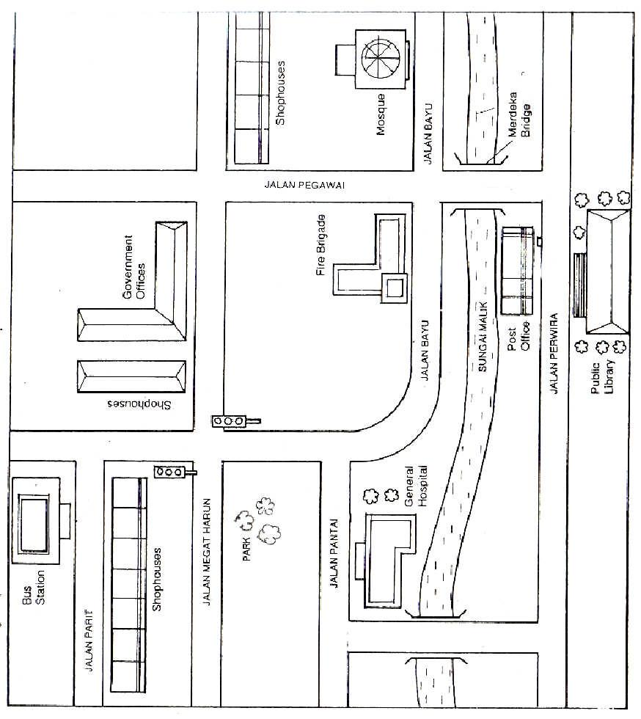

6

Appendix 4 : Map of Taman Desa (with the route)
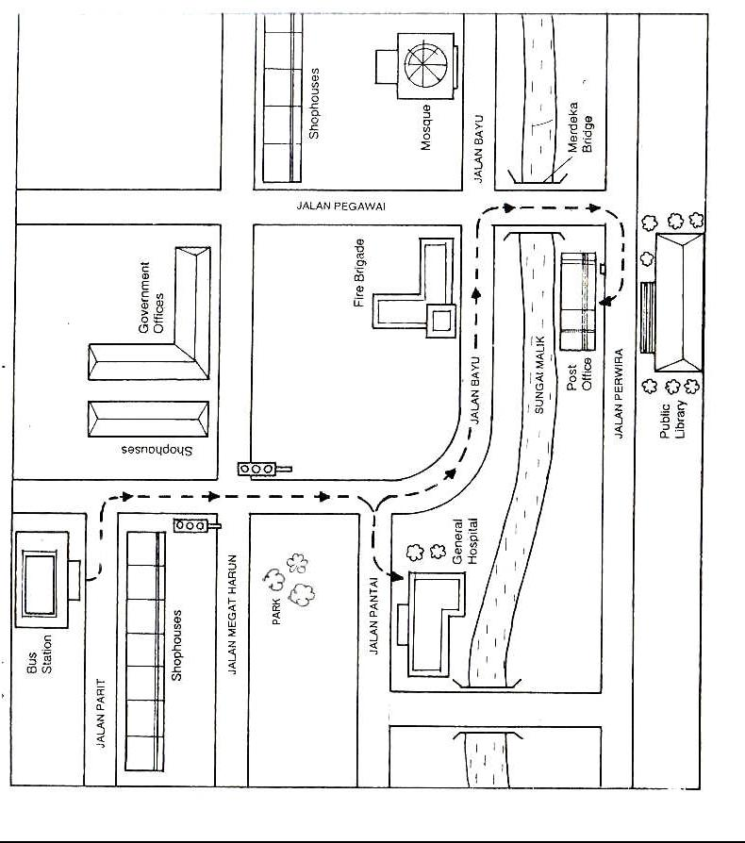

7

Appendix 5 : Map of The Fishy Town (TASK A)

Task A:

- In your group, decide on a place to go from the destination you are now (marked with the star).
- Then draw the route on the map and make 3-5 sentences to “describe” the route. You must use the preposition learned.

The Fishy Town
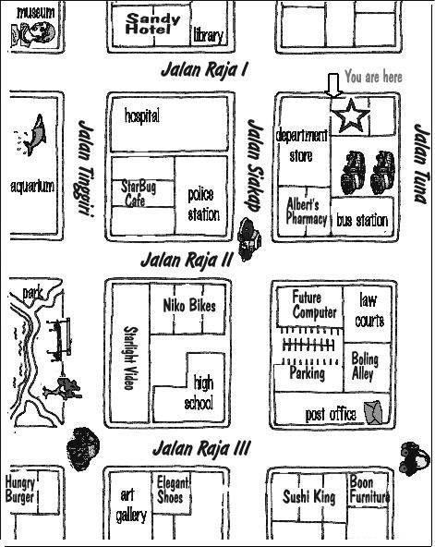

Bank

Cinema

8

Appendix 6 : Map of The Fishy Town (TASK B)

Task B:

- Listen carefully to the “descriptions” by the other group.
- Then draw the route described by the group in this map and see if you can get it right.

The Fishy Town
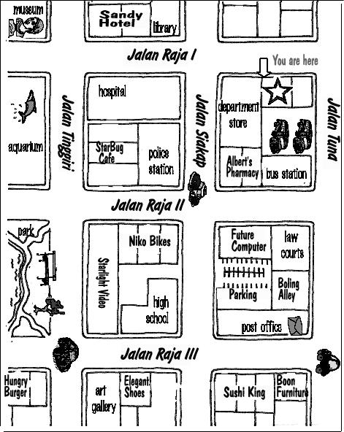

Bank

Cinema

9

