Form: 9
Date:
Theme: London
Aims: 1. to teach children to use the new words in their speech;
2. to develop skills of writing and speaking about London;
3. to bring up to respect each other.
The visual aids: cards, slide show.
The Basic part
I Organization moment. (7 minutes)
- Greeting. Good morning, class! How are you? Sit down, please. Who is on duty today? Who is absent today?

- Warm up.
Look at the blackboard there are some pictures, tell the names of these buildings and where they are situated.
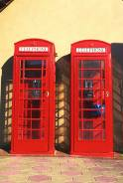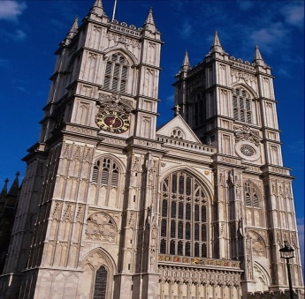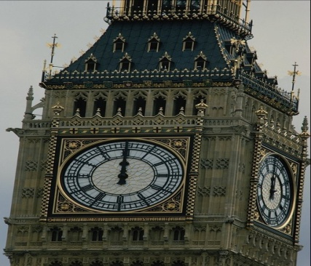

3. Checking the home task.
What was your home task? Let’s check it. Now I will check. And now who wants to be the first

II The main part (33 minutes)
- Introduction.
To tell the children the theme and the aims of the lesson.

- Reading and speaking.
Open your books on pages 66-67, there is a text read it and try to understand the meaning, the new words help you.
Then work in pairs and tell the difference between:
  - Conductor and conductress;
  - Inspector and bus driver;
  - Single-decker and double-decker;
  - Bus and coach.
- Writing.
Look at the exercise 2 on page 67, there are some words; your task is making up sentences as shown in the example.
The bus having only one floor is a single-decker.
The bus ___________________ is a double-decker.
The person __________________________ is a driver.
The man _______________________________ is a conductor.
The man _____________________________ is an inspector.

- Speaking.
Look at the blackboard there is a chart. All forms of transport have advantages and disadvantages. Look at the table and in groups agree on advantages and disadvantages for each form.
Example: do you think buses are crowded in your city?
Are there delays when you travel by air? Plane? Etc.
 | bus | train | car | bicycle | plane | taxi
crowded
cheap
safe
dirty
delay
slow
queues
Now conclude.
We think that ______ are better than ________. We decided that _______ is the best/worst, it has most/least advantages.

- Time to relax.

- Writing.
Compare the system of public transport in London and your city. The slide show and the text help you.
Things in common:
- Traffic jam

My city
- No underground

3.
4.
5.
London
- 3000 underground stations
2.
3.
4.
5.

- Speaking.
Look at the exercise 5 on page 68, there are some expressions; your task is to make up sentences by using these expressions and expressions from exercise 6.

- Grammar.
Look at the grammar on page 69 and try to understand it. Then ask each other the questions exercise 8.

III The end of the lesson. (5 minutes)
- Home task. Open your diaries and write down the home task. Your home task will be exercise 8 on page 69 to make sentences by using these prepositions and to learn the words.
- Putting marks. You were very activity today at the lesson. Give me your diaries for putting marks.
- Reflex ion. What did you do at the lesson?
What did we talk about?
What the new words did you have today?
Тексерілді _________________

