Преподаватель: Шайдуллина Диана Рустамовна
Школа: «Арская средняя школа №1 им В.Ф.Ежкова с углубленным изучением отдельных предметов»
Класс: 5
Тема: Great Britain

Цель: Развитие умений монологической речи.

Задачи : 1. Активизировать в речи обучающихся лексику по теме.
2. Практиковать в устной речи (монолог, диалог – расспрос).
3. Расширить знание учащихся о Великобритании, ее политических и
географических особенностях.
4.Воспитывать интерес к культуре и истории страны изучаемого языка.

План урока:

- Начало урока
- Организационный момент.

а) – приветствие:
- Hello boys and girls. I’m very glad to see you. Great each other and smile to each other.

b) - беседа о погоде:
- What the weather like is it today? Answer this question using as many adjectives as possible. So it’s time for Rally Robin. You are to do RR with your shoulder partners. (называют прилагательные)

2.Опрос д/з
- Let’s check your home task. Your home task was to revise the irregular verbs. Everyone has a sheet of paper with a task. You are to complete the table one by one. So, it’s time for Round Robin.

do | … | … | …
… | came | … | …
… | … / … | been | …
… | … | … | строить
begin | … | …
… | … | cost | стоить
… | drank | … | …
become | … | … | …

-Well done! Let’s cheer each other! GREAT! (делаем фейерверк)

- Основная часть урока.

1)Совершенствование умение навыков монологической речи по теме:«The British Isles»

-At the last lesson we read topic about the land, people and the geographical position of GB. And I want you to tell this topic to each other using Timed Pair Share. Work with your shoulder partners. But at first you have 30 seconds to think it over. Start!
-And now numbers one will tell us about the British Isles. So one of you will begin, one of you will continue and one of you will finish.
(3 ученика – 1ые номера, опираясь на карту GB рассказывают о Соединенном Королевстве, о географическом положении, о ее частях, символах, о флаге и о её людях и языке.)

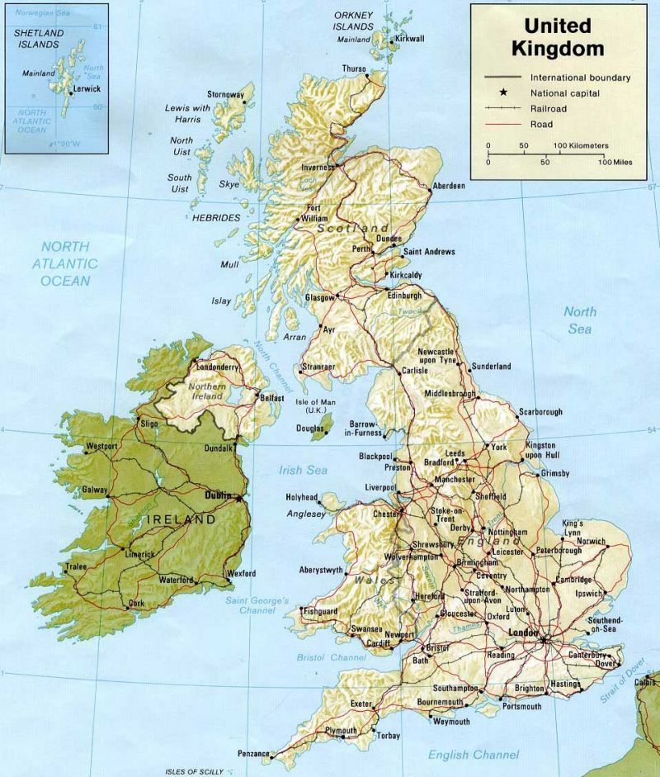

- Answer the questions given on the sheets of paper which are in the envelopes on your tables. Let’s do this task using Rally Robin. Work with your shoulder partners. (ученики отвечают на вопросы, данные на листочках).

1. Where is the UK situated?
2. Why do you think the UK is called “the island state”?
3. How many parts does the UK consist of? What are they? What are their capitals?
4. What languages are spoken in England, Wales, Scotland and Northern Ireland?
5. How many people live in Britain?
6. What is The Union Jack?
7. What are the emblems of England, Wales, Scotland and Northern Ireland?
8. Name water bodies around the UK.

- Now answer my questions, but before you answer discuss your answers with your face partners.
-Good! I like your answer!

2) -You know a lot about the GB. So let’s check your knowledge using Corners. Look! In the corners of the room you can see four parts of the UK. They are: England, Scotland, Wales and Northern Ireland. In the envelopes which are on the tables you have sheets of paper with the names of the symbols and the capitals of these countries. And you are to choose the right corner. Your corner. So, at first, you are to choose the words you like and to decide where you are to go.
(обсуждают и расходятся по углам).
-Let’s check! But at first discuss, if you are right or not. You have 15 seconds and then one of you will answer.(уже стоя в углах обсуждают правильные ли они выбрали углы)
-I’m satisfied with your work!

4)Развитие УН монологической речи.
-You know much about the UK in oral form. But I wonder whether you can do the same in written form?
- Now, it’s time for Jot Thoughts. Everyone has three sheets of paper and you are to write down the words connected with GB. So what is GB associated with for you? You are to write one word on one sheet of paper and put a sheet with a word in the centre of the table saying this word to your partners. (пишут слова на листочках и проговаривают их вслух)
-Mix the papers and choose only 9 sheets to make a table and to play Tic-Tac-Toe. You have to choose three words and make sentences with them. The words may be down, across or diagonally. Make the sentences and read them to each other one by one. If you finish, give me a sign.
- Praise and Thank your partners!

III. Заключительная часть.

1)Закрепление.
-The last task is Quiz-Quiz-Trade. You have to write down a question on the sheets of paper you have. This question should be connected with our today’s theme. And you should write down an answer to this question on the other side of а paper. You have 15 seconds and you can use your books.
-Now stand up! Pair up! Ask questions and change your papers! You should change the papers only twice and then take your seats! Don’t forget to Praise and Thank your partners!

2)-There are several minutes till the end of the lesson. I’d like you to fill your tickets for leaving the lesson using 3-2-1.
-At first, you are to write down three the most important moments, which you learnt studying this theme.
-At the second, you are to write two moments, you would like to share with the others from your class.
-Thirdly, a moment you didn’t understand or a question you wanted to ask but you didn’t ask.
(пишут на стикерах и прикрепляют к стене.)
-Put the stickers on the board with a special parking on it.

3)Подведение итогов
-It’s time to say good bye!!
- Оценки
- д/з
-Your home task is to revise the irregular verbs.

-Thanks for your lesson! Good bye!

London

Edinburgh

Cardiff

Belfast

Red rose

Shamrock

Daffodil

Thistle

London

Edinburgh

Cardiff

Belfast

Red rose

Shamrock

Daffodil

Thistle

