The Beatles
1.Reading. 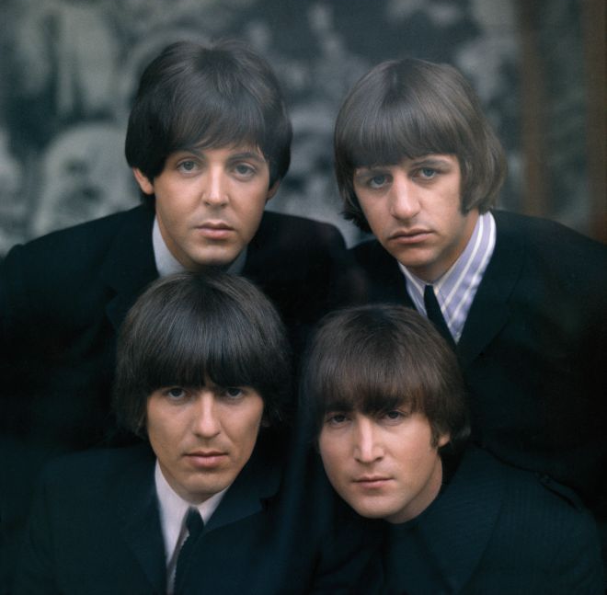
Read the text and choose the most suitable heading from the list A-E for each part 1-4. There is one extra heading.
A) The Beatles Story Museum.
B) John’s hobbies.
C) Left-handed person.
D) Ringo’s family .
E) Education.
- __________
The Beatles Story Museum was founded by Ringo Starr in April 1984. In the Museum Halls you see the Beatles’ films, books and magazines. You can also buy different souvenirs, stamps, plates and cups with the Beatles’ portraits, or records and cassettes with their songs.
- ___________
John enjoyed painting. His favourite book was Alice in Wonderland. Later, he was fond of reading books by Robert Louis Stevenson and Edgar Allan Poe, or books about artists. His mother Julia encouraged her son to pursue musical hobbies, teaching him to play the harmonica. Julia later bought a guitar for her son and John spent a lot of hours playing different melodies.

- ___________
At school Paul found out that he was left-handed – he couldn’t write with his right hand.
The McCartney family loved music. Paul was keen on football, but music didn’t play an important part in his childhood. He learned to compose songs on his piano very quickly. Paul asked his father to buy him a guitar. He had to rearrange the strings on his guitar because he played with his left hand.
4.____________
Ringo Starr was born on July 7, 1940. His father, Richard Henry Parkin Starki, worked as a baker. His wife, Elsie Gleeve, was a waitress in a bar.
Elsie worked hard, which is why little Richard had to stay alone or at their neighbour’s. Richard was very sociable as a result. He was a very weak boy and often missed classes at school. He was invited to join the group in summer 1962. He was paid 25 pounds a week.

2.Listening.

Yellow submarine.

Complete some lines from the song with the missing words.

In the town where I ___________ born,
_______ a man who __________ to sea,
And he ___________ us of his life,
In the land of submarines,

So we _________ on to the sun,
Till we ___________ the sea green,
And we _________ beneath the waves,
In our yellow submarine,

We all live in a yellow submarine,
Yellow submarine, yellow submarine,
We all live in a yellow submarine,
Yellow submarine, yellow submarine.

3.Grammar and Vocabulary.

Use the words given in capitals in the Past Simple.

In the town where I __________ born, BE
___________ a man who ____________ to sea, LIVE SAIL
And he _______________ us of his life, TELL
In the land of submarines.

So we _____________ on to the sun, SAIL
Till we ____________ the sea green, FIND
And we _____________ beneath the waves, LIVE
In our yellow submarine.

4.Writing.

Answer the following question.

“Would you like to live in a yellow submarine ? Why?”

