Государственное общеобразовательное учреждение
«Санкт-Петербургская средняя общеобразовательная школа № 504 с углубленным изучением английского языка»
Кировского района

План урока в 4 класса
«Дом, мой милый дом»

подготовила
учитель английского языка
Федосеенко Марина Анатольевна

г. Санкт-Петербург
2012
Методическая разработка урока по теме «Дом, милый дом»
Тип урока: урок-обобщение
Используемые учебники и учебные пособия: УМК И.Н. Верещагиной, О.В. Афанасьевой «Учебник для школ с углубленным изучением английского языка IV класс»
Используемое оборудование: карточки с заданиями, магнитная доска, презентация, компьютер, мультимедийный экран.
Краткое описание: Завершающий урок по теме “Home, sweet home”
Цель: Развитие навыков монологической речи
Задачи:
- Учебные – организация работы по тренировке навыков говорения, аудирования, чтения и письма;
- Развивающие – создание комфортных условий для развития творческих способностей учащихся;
- Познавательные – расширение социокультурной компетенции учащихся;
- Воспитательные – формирование потребности к сотрудничеству и взаимопомощи при работе в парах, привитие любви к родному дому;
Этапы урока:
- Организационный момент
- Постановка целей и задач урока
- Фонетическая зарядка
- Речевая зарядка
- Развитие навыков аудирования
- Развитие навыков чтения и письма
- Физ. минутка
- Формирование навыков говорения
- Подведение итогов урока
Этап урока | Оформление доски | Речевые действия учителя | Речевые действия учащихся
Организационный момент |  | Good morning class. I am glad to see you. How are you?  Sit down please. What day is it today? What date is it today? What is the weather like today? | Good morning teacher, We are glad to see you too. We are fine thanks. It is Wednesday. Today is the 16th of May. The weather is sunny and warm.
Постановка целей и задач урока. | 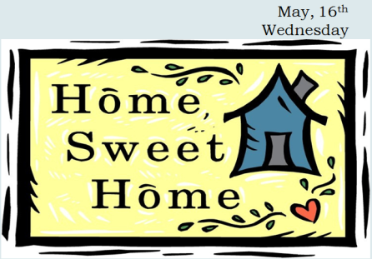 | Look at the screen and tell me please what the topic of our lesson is?  What is it about? | The topic of our lesson is Place we live in.  It is about houses and flats where we live.
 | 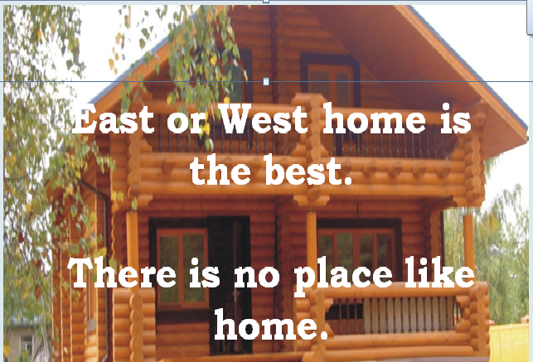  Plan of our lesson:  - Remember proverbs about home.  - Read the poem and answer the questions about it.  - Revise the words on the topic “Place We Live In”.  - Compare typical English and Russian places of living.  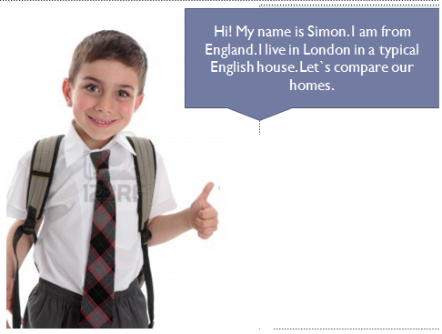 | Home, sweet home is a proverb. Who can try to translate it?  Do you know any other proverbs about home in English?  Today we are going to revise the words about home and talk about typical English and Russian homes. We will compare them.  Look at the screen. This is Simon, he is from England. Today Simon is going to tell us about his place of living. Let`s compare Russian and English houses. | Дом, милый дом.  East or West home is the best. There is no place like home
Фонетическая зарядка | 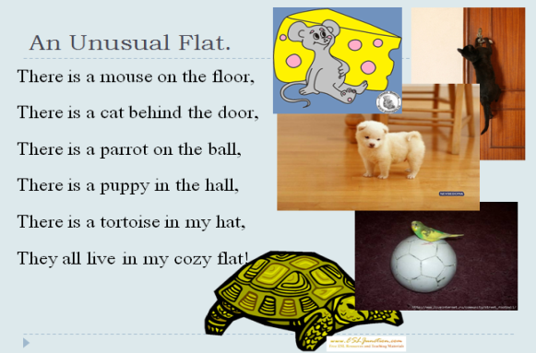  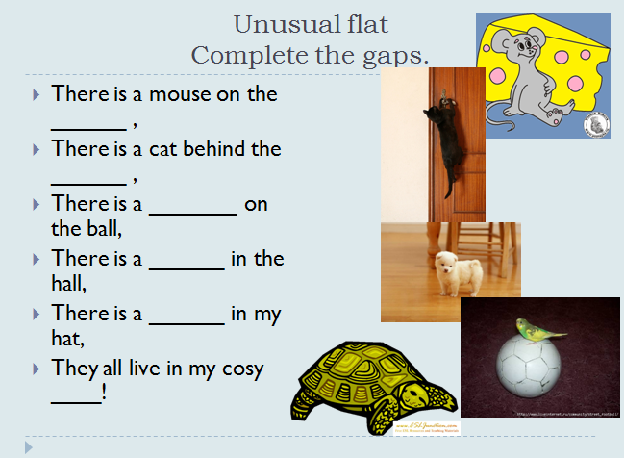 | Look at the screen and repeat after me: Let`s read altogether.  Well done, now let`s read the poem line by line.  Who can read the whole poem?  Complete the gaps in the poem. | There is a mouse on the floor,  There is a cat behind the door,  There is a parrot on the ball,  There is a puppy in the hall,  There is a tortoise in my hat,  They all live in my cosy flat!  There is a mouse on the floor,  There is a cat behind the door,  There is a parrot on the ball,  There is a puppy in the hall,  There is a tortoise in my hat,  They all live in my cosy flat!
Речевая зарядка |  | Now answer my questions, please.  1. Is there a mouse on the floor?  2. Is there a cat or a parrot behind the door?  3. Is there a puppy on the ball?  4. What is there in my hat?  5. Where do the animals live?  Well done! | Yes, there is  There is a cat behind the door  No, there isn`t  There is a tortoise  They all live in a cosy flat
Активизация пройденных лексических единиц | Вниманию учащихся предлагаются слайды с изображениями предметов | Name the pictures  Listen the description and guess what it is. You will get one point for each correct answer.  1. A thing we can lock the door with  2. A place where we can live in  3. A thing we can sit and read before the fire  4. A room where we have dinner  5. A place to sit by in the armchair and get warm  6. A thing where we keep our clothes  7. A thing that helps us to read when it is dark in the room  8. Things which are on the windows and make the room lovely  9. A thing in the kitchen to cook our food  10. A thing in the kitchen where we can wash up  11. A thing where we can see our faces  12. A thing at what we sit and do homework  13. A thing that keeps food fresh and cold  14. A thing where we keep books  15. A thing where we sleep  16. A thing that tells us time  17. A thing that is on the floor and makes the room comfortable  18. A thing that helps us study or play  19. A place where we wash our faces and hands  20. A thing where we keep cups plates and dishes  Count your points. Who is the winner? | Lamp, chair, armchair, sofa, table, mirror, bookcase, curtains, TV, watch, telephone, computer, flower, fireplace, cooker.)  а key  a flat or a house  an armchair or a chair  a dining room or a kitchen  a fireplace  a lamp  curtains  a cooker  a sink  a mirror  a desk  a fridge  a bookcase or a shelf  a bed or a sofa  a clock  a carpet  a computer  a bathroom  a cupboard
Развитие навыков чтения и письма | My house  I  We live in the дом,  It`s not very большой.  With кухня and ванная  I like it very much.  II  The стол is brown,  The окноis white,  The кровать is yellow,  The curtains are bright.  III  My room is nice:  A книжный шкаф-next door,  A colourful ковер  Is on the пол.  IV  There are many игрушки,  I like to play.  My друзья can come  And have fun every day. | Now divide into two groups.  This is a poem but the author doesn`t know English well, he forgot some English words.  Can you help him?  Does the author like his house? Can you prove it by the text? | Yes, we can  We live in the house  It`s not very big  With kitchen and bathroom  The table is brown,  The window is white,  The bed is yellow,  A bookcase – next door,  A colourful carpet  Is on the floor  There are many toys  There are many toys  My friends can come  And have fun every day.
Развитие лексико-грамматических навыков | 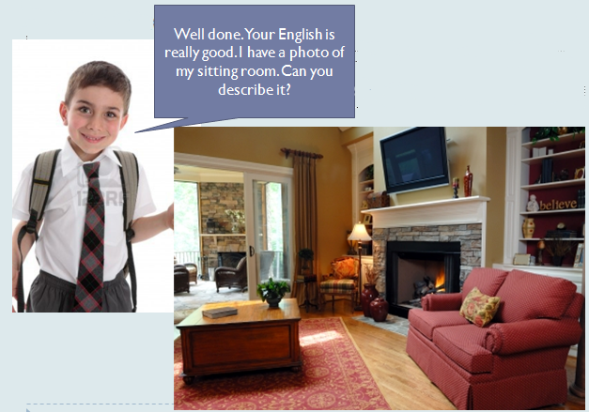  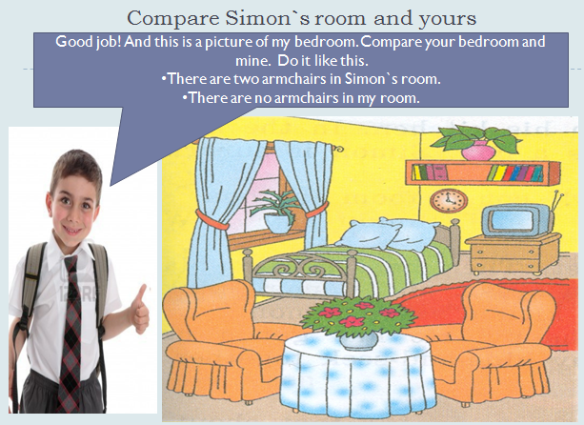 | Describe Simon`s room, please.  Well done and now let`s compare Simon`s room and yours. | There is a carpet on the floor. There is a TV on the wall. Under the TV there is a fire place. Near the fireplace there is a comfortable sofa. There is a table in the middle of the room. There are curtains on the window. The curtains are brown.  There are three flowers in Simon`s room.  There is one flower in my room.
Физ. минутка | На проекторе воспроизводится видео физ. минутки | Are you tired? Would you like to have a rest? Repeat the movements after the main character on the screen. | Ученики повторяют движения за главным героем видео ролика
Развитие навыков монологической речи | 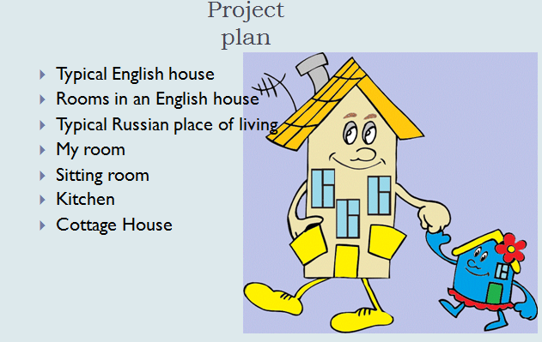 | And now let`s to compare typical English and Russian houses. You prepared reports about different houses. Look at the screen, that`s the plan of your projects. Now you are welcome with your reports and pictures.  Listen attentively after the presentation we will choose the best presentation.  Thank you for your presentations. Now choose the best one.  What project do you like most of all?  What are the differences between English and Russian houses? | Каждый ученик выступает с приготовленным сообщением.
Подведение итогов урока |  | Tell me please what did we do at the lesson?  What was interesting? What was difficult? What was easy? What do you like? | We read the poem, we did the quiz, and we completed the poem and compared English and Russian homes.
Объяснение домашнего задания |  | So, your home task will be to prepare the story about your favorite room in your flat or house.

Библиография:
УМК Верещагиной “English IV”
УМК Биболетовой “Enjoy English” для 5 класса
Видеоролик “Hockey pockey”

