Автор: Феночкина Наталия Юрьевна
Место работы: МБОУ СОШ №16 г. Кропоткин
Должность: Учитель английского языка

План-конспект урока по английскому языку в 6 классе

Тема: “Home, Sweet Home.”
Цели:
1. Активизировать употребление лексики по теме «Дом».
2. Практиковать учащихся во всех видах деятельности.
3. Проконтролировать усвоение учащимися грамматического материала .

Оборудование: картинки по теме «Дом», плакаты, раздаточные тематические карточки.

Ход урока:
1. Beginning of the lesson.

- Good afternoon, children! I’m glad to see you. Sit down! We are going to have an unusual lesson today, the lesson-competition. Two teams “The Best” and “The Cleverest” will compete and show their knowledge in the topic “Home, Sweet Home”. The competition consists of several tasks. If you answer correct the team will get one point. You will get nothing if you answer wrong.
2. The first task.
Т: Let’s revise our vocabulary. You can see two posters for each team on the blackboard. One pupil of the team much write these words right.

Cha…r, furni…ure, booksh…lf, refrigerato…, cu…board, war…robe, win…ows, ca…pet, sof…,
bedro…m.

Т: Let’s check: Chair, furniture, bookshelf, refrigerator, cupboard, wardrobe, windows, carpet, sofa,bedroom.

3. The second task.
Т: Which word doesn’t fit? Find this word in each line.
a) a table, a desk, a sofa, nice, a chair
b) a hall, a bedroom, a picture, a living-room
c) to clean the house, to watch TV, to sweep the floor, to wash the dishes
d) a refrigerator, a store, a cupboard, a curtain, a garage

Т: Let’s check: подчеркиваются слова.

4. The third task.
Т: Read and match the words:
1. watch a) music
2. listen b) newspaper
3. read c) dinner
4. do d) the floor
5. sweep e) the cooking
6. have f) TV

Т: Let’s check: 1f, 2a, 3b, 4e, 5d, 6c

5. The fourth task.
Т: What English proverbs about home do you know? Read and translate.
1. East or West, home is best.
2. My home is my castle.
3. Every bird likes its own nest.
4. There is no place like home.

Т: Let’s check:
1. Везде хорошо, а дома лучше.
2. Мой дом – моя крепость.
3. Каждый кулик своё болото хвалит.
4. Нет места лучше дома .

6. The fifth task.
Т: Let’s revise preposition.
1. The pictures are … the wall.
2. The telephone is … the bed.
3. The carpet is … the floor.
4. Our room is comfortable because there are nice curtains … the windows.
5. There isn’t a wardrobe …. my room.

Т: Let’s check: 1. on 2. near 3. on 4. on 5. in

7. The sixth task.
Т: Let’s describe the picture. (использование ситуативных картинок).You may ask the questions.

8. The seventh task.
Т: Let’s make up sentences. Be attentive! The words are mixed.
1. There, room, in, is, sofa, nice, a, the.
2. What, armchairs, are, colour, the?
3. Curtains, on, the, windows, the, are.

Т: Let’s check:
1. There is a nice sofa in the room.
2. What colour are the armchairs?
3. The curtains are on the windows.

9. The eighth task.
Т: Let’s do some task for grammar.
1).1. We … in the UK last summer.
2. Our friends … at home now.
3. There … much furniture in the room.
4. There … a window, a sofa and the table in the room.
5. …. there any children in the yard an hour ago?

Т: Let’s check:
1. were
2. are
3. is
4. is
5. were

2). 1. Ann (eat, eats) in the kitchen.
2. We (have, has) many rooms in the house.
3. They (played, plays) in the living-room an hour ago.
4. My sister (sleep, is sleeping, sleeps) in the bedroom now.
5. He (keep, keeps) food in the fridge.
Т: Let’s check: подчеркиваются слова.

10. The ninth task.
Т: I will read small text and you must listen to them and then give me answer on the question: what kind of a room is it?

1.This room is big. There is a sofa, two armchairs, a TV set. There are pictures on the wall.
2. The room is small. There is a bed, a mirror, a wardrobe. The room is very nice.
3. The room is small. There is a desk, two beds. There are some bookshelves. There are toys in the floor.
4. The room is large. In the middle of the room there is a big table. There are some chairs round the table. On the table there are plates and cups, forks and spoons.
5. This is not a room. There is a telephone, a hall-stand. There are pictures on the wall.

Т: Let’s check: 1 – living room , 2 – bedroom, 3 – Children’s room ,4 – dining room,
5 – hall.

Т: Our competition is coming to an end, we have the last task. It will be a crossword. Both teams should do the crossword.
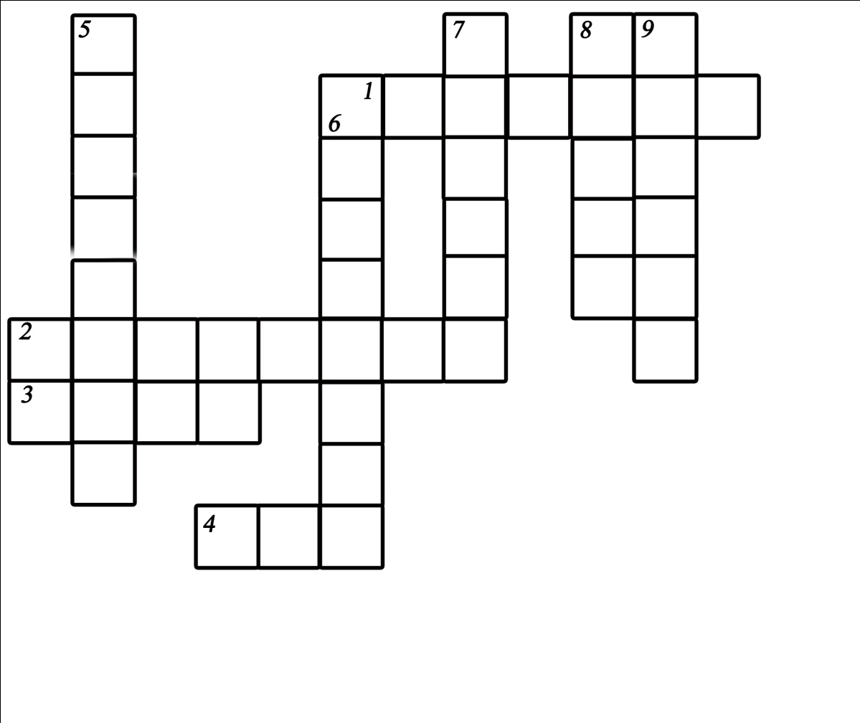
Горизонталь:
1. Занавеска
2. Шкаф для одежды
3. Раковина
4. Кровать
Вертикаль:
5. Кресло
6. Посудный шкаф
7. Холодильник
8. Стол
9. Зеркало

Т: I think both teams are clever, but ….. is better.
Your marks are: ……Thank you for the lesson.Goodbye.

