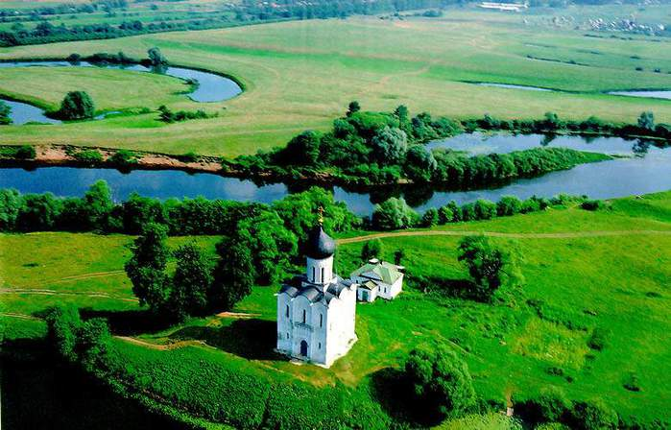
In the heart of Russia
If you go to the North-East of Moscow you will come to Vladimir region. The total area of the region is 29 000 square kilometers .It stretches for 170 kilometers from north to south and for 280 kilometers from east to west.
The geographical position of the region is favorable due to the main lines and the highway connecting Moscow with the Ural region , Siberia and even the Far East. Vladimir region consists of 16 districts. The population is approximately 1,5 million people. Within the territory of the region there is a great number of small rivers, the longest one is the river Klyazma. The region is rich in lakes(there are more than 300 lakes there, some of them are identified of prehistoric period in Yuriev –Polsky district ).The climate is mild - continental ,we can define four clear seasons in the region-it’s not so cold in winter and it’s rather warm in summer.
Vladimir region is one of the biggest industrial centers in Russia. Today it produces electronic equipment, chemical products, furniture and TV-sets, sweets and canned goods , footwear and clothes and other things. We’ve got a lot of plants and factories ,enterprises and joint ventures, developing business centers and economical exhibitions.
Vladimir is also a sporting center. Plenty of stadiums and skating rinks, gyms and swimming pools are available at the city. The Regional Gymnastics school is famous all over the wall, the outstanding Russian athletes N.Andrianov, ,Y.Korolev, Y.Rezanov lived here.
Speaking about cultural life we should mention two permanent theatres: the Puppet and the Drama ones, the latter is over 160 years old. The city is famous for its Chamber Choir, founded by Ed. Markin. The Vladimir landscape painting school is one of the best in the Russian Artist’s Professional Community, the works of M.Izotov, V.Yukin, K.Britov, B.Franzusov ,V.Kokurin are regularly displayed in European countries and well- known in the world.
Vladimir is one of the largest tourist centers in Russia and in the world. It’s a part of the ”Golden Ring”. A great number of visitors come to Vladimir to enjoy its picturesque sights and admire the historical monuments, numerous churches, cathedrals which are the world famous. The “pearls” of the collection -: the Church of the Intercession on the Nerl, the Dmitrievsky Cathedral, the Assumption Cathedral, the Golden Gates-possess unique architectural landmarks. Vladimir is known by its surburbs, Suzdal is one of them. People living in Vladimir region are really proud of their native land.

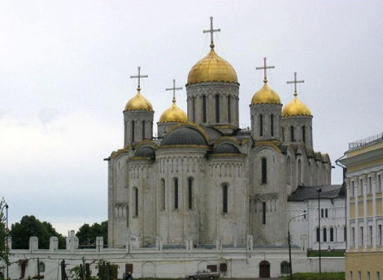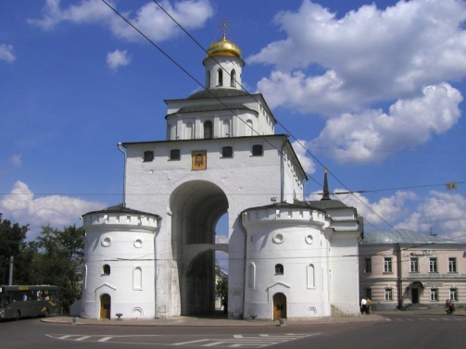
I. Answer the questions about the text:
1. What is the geographical position of Vladimir region?
2. Is the position of the region favorable?
3. What kind of climate can we name in Vladimir?
4. Vladimir is the developed industrial center, isn’t it?
5. Plenty of goods are produced in region today, aren’t they?
6. What sports facilities are available in the region?
7. Can you name the outstanding Vladimir athletes?
8. Is the city famous for its cultural or political life?
9. Do many visitors come to Vladimir to enjoy its sights and admire the history?
10. Are people living in Vladimir really proud of their native land?
II. Translate the following phrases:
1. A great number of-
2. To be rich in-
3. Plenty of-
4. To be famous for-
5. Well-known-
6. Should mention-
7. To be displayed-
8. To be available-
9. To be known by-
10. To be proud of-
III. Find English equivalents to the Russian word phrases:
1.Удобное расположение 7. Доисторический период
2.Оборудование для электроники 8.Товары народного потребления
3.Совместное предприятие 9. Выставка экономических товаров
4.Школа живописи 10.Постоянный театр
5.Спортивное оборудование 11. Выдающиеся спортсмены
6.Живописные виды 12.Жемчужина коллекции

IV. Choose the correct synonym to the title:
The History of the Vladimir region,
The part of the Golden Ring,
The pearls of the architectural collection,
The best region in Russia
In the center of Russia
V. Rearrange the words to make a saying:
Home, no , place ,like, is, there.
Best , east, home ,or, west.
Castle, my, is, home.
