Муниципальное общеобразовательное учреждение
«Нижнекамская общеобразовательная школа №7»
города Нижнекамска Республики Татарстан

Внеклассное мероприятие
по английскому языку
«Мой родной край»
(Нижнекамск - город моей мечты)

Подготовили:
Фассахова Роза Габбасовна,
учитель английского языка,
Нурмухаметова Эльвира Ирековна,
учитель английского языка
Нижнекамск – город моей мечты
Воспитание гражданина и патриота, который знает и любит свою Родину, является очень актуальной задачей сегодня.
Большое значение для формирования, расширения и углубления представлений о родном крае, воспитания любви к родному краю имеет применение в учебно-воспитательном процессе местного краеведческого материала.
Мы должны знать, что каждый человек – часть своего народа, что у каждого человека есть своя Родина. Национальная культура входит в наше сознание вместе с генами родителей, с культурой других народов. Душа народа едина, но она проявляется по-разному в разных видах искусства: в песне, танцах, сказках, легендах.
Чувство Родины начинается с отношения к членам семьи, к самым близким людям. Это корни, которые связывают его с родным домом.
Цели:
1.Рассмотрение исторической преемственности поколений;
2.Сохранение и развитие национальной культуры;
3.Воспитание бережного отношения к историческому и культурному наследию родного края.
Много есть городов на просторах
необъятной, чудной земли.
Но лишь ты, Нижнекамск, сердцу дорог,
я тебе объясняюсь в любви!

Nizhnekamsk is the town of my dream.
The young generation should know how to keep and develop the national culture, its values. We understand that every person has his own motherland. Our motherland is Russia.
Welcome to Russia.
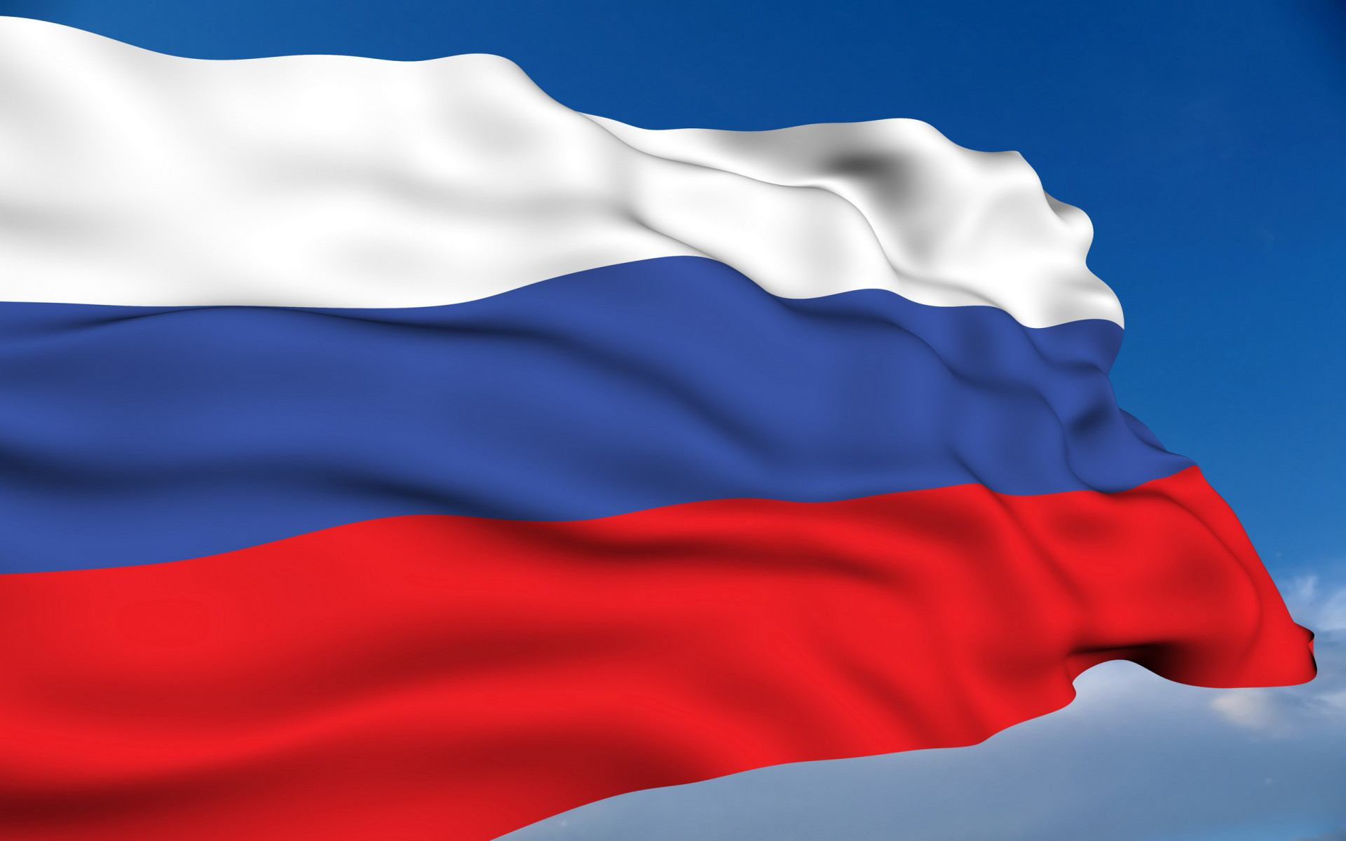
Russia is the largest country in the world. It is also the eighth most populous nation with 143 million people. The Russian federation comprises 83 federal subjects. One of them is Tatarstan.
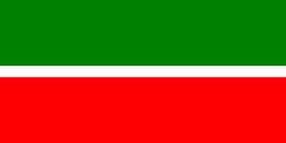
The republic of Tatarstan is a federal subject of Russia located in the Volga Federal District. Its capital is the city of Kazan, which is one of Russia’s largest and most prosperous cities.
The unofficial motto of Tatarstan is: Bez buldirabiz! (We can!)

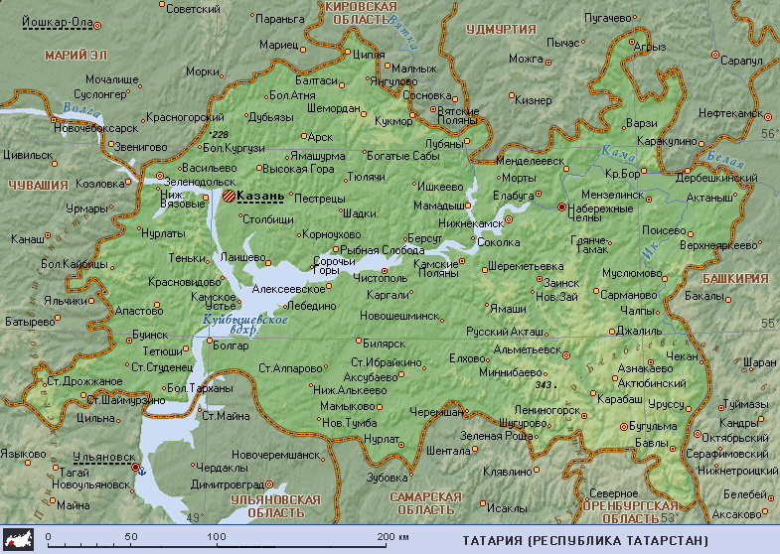
Tatarstan is one of the largest socio-economic, scientific and political centers of the Volga Region. It is located at the center of the Russian Federation.

The capital of Tatarstan is Kazan. Kazan is one of the oldest and most beautiful cities in the Volga region.
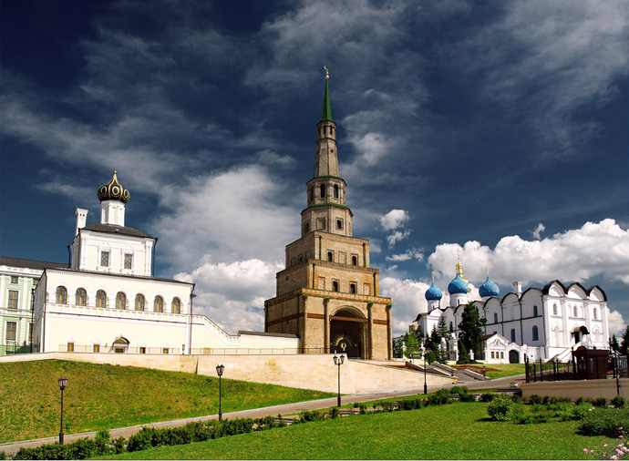
The historical places of Kazan
The republic has a huge water resource. The Volga system is of great importance to Russia and Tatarstan. The Volga, the Kama are the longest rivers. The cities situated on the banks of the Kama are: Naberezhnye Chelny, Nizhnekamsk, etc. Nizhnekamsk is one of the most beautiful and cleanest towns in Russia. It is considered to be the most comfortable town. It is famous all over the world because it is one of the top centers of oil treatment industry.
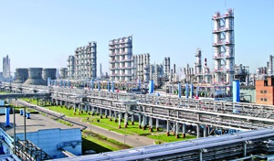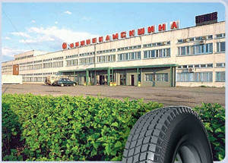

The largest industrial enterprises are “ Nizhnekamskneftekhim”, “Nizhnekamskshina”.

Nizhnekamsk is not large. It is very multinational. There are many interesting festivals and holidays. The most popular Tatar national holiday is Sabantuy. Every year thousands of people gather to celebrate this holiday. They take part in different games, sing songs, dance and relax.

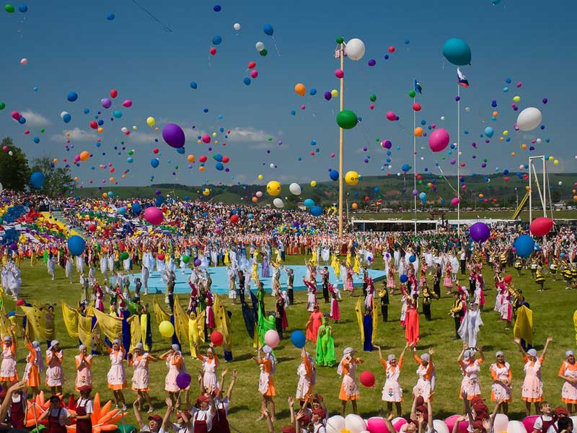
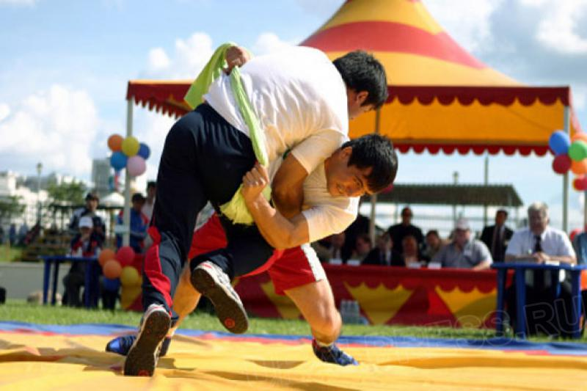
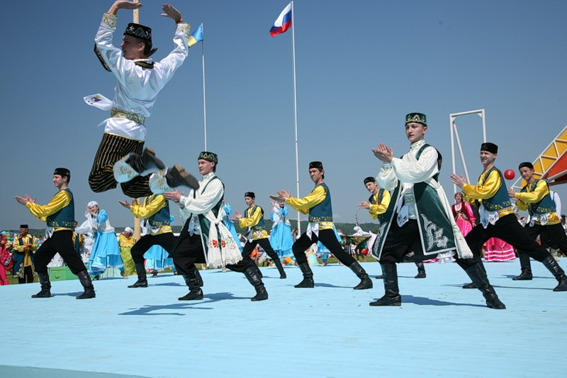
Sabantuy is a symbol of Tatarstan
There are many interesting places to visit in Nizhnekamsk. They are: museums, theatres, cinemas, beautiful parks and amusement centers.
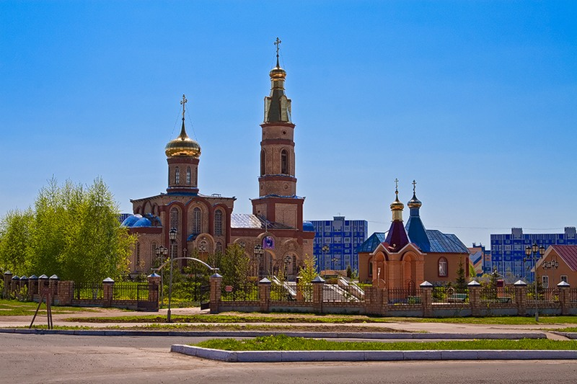
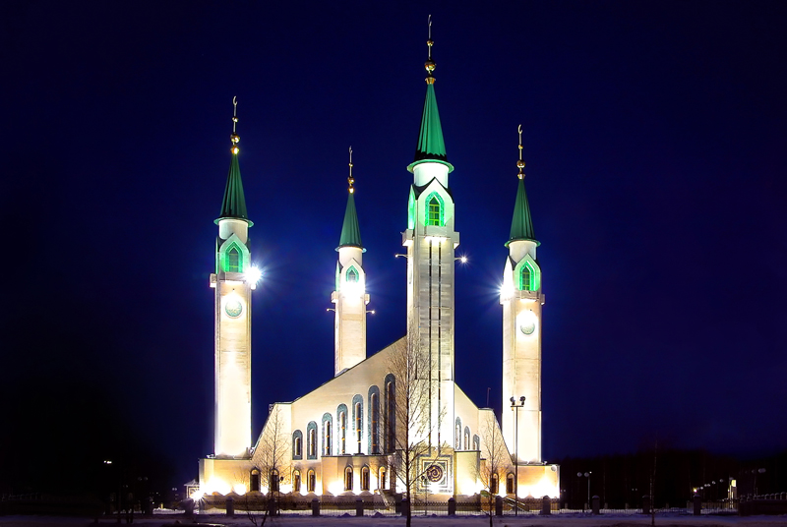
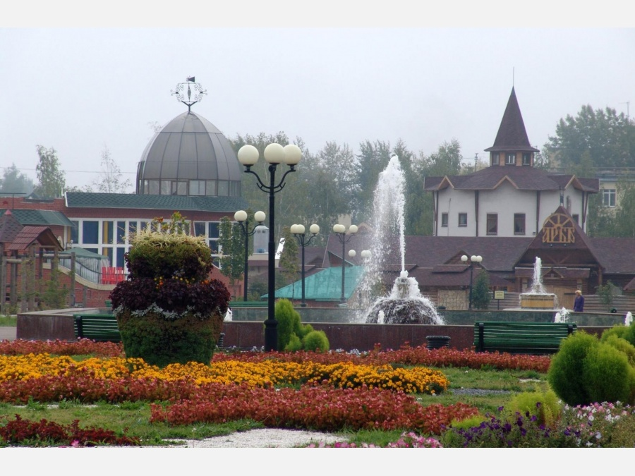

Lemaev Square

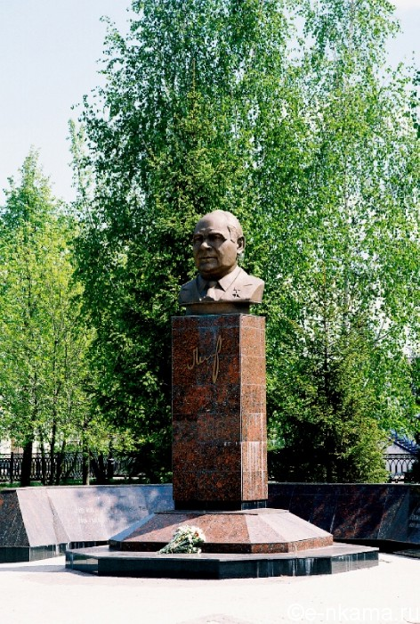
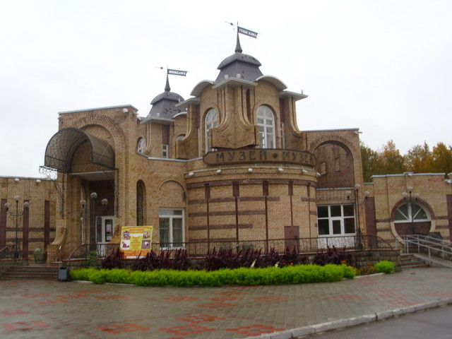
Our town museum
The most popular place is the Red Key with its legend. All people love this place and come here to celebrate wedding days or relax among the trees with view to the river Kama.
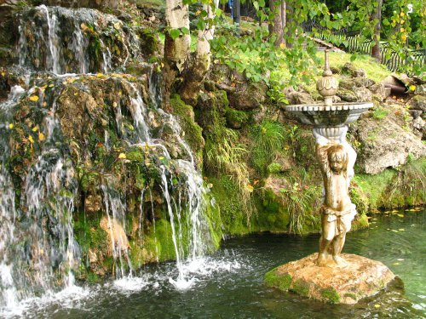
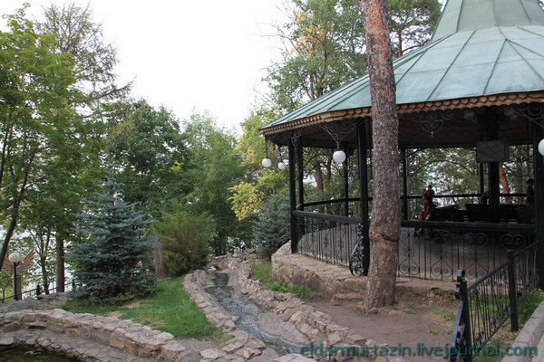
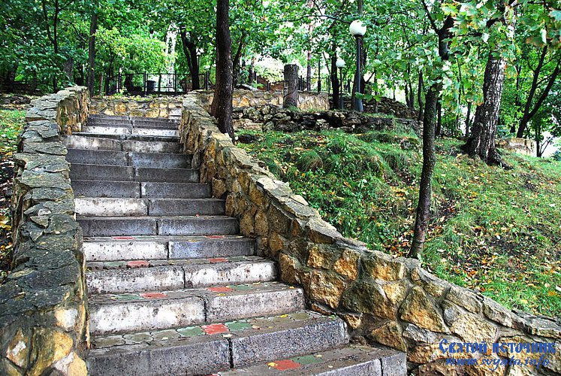
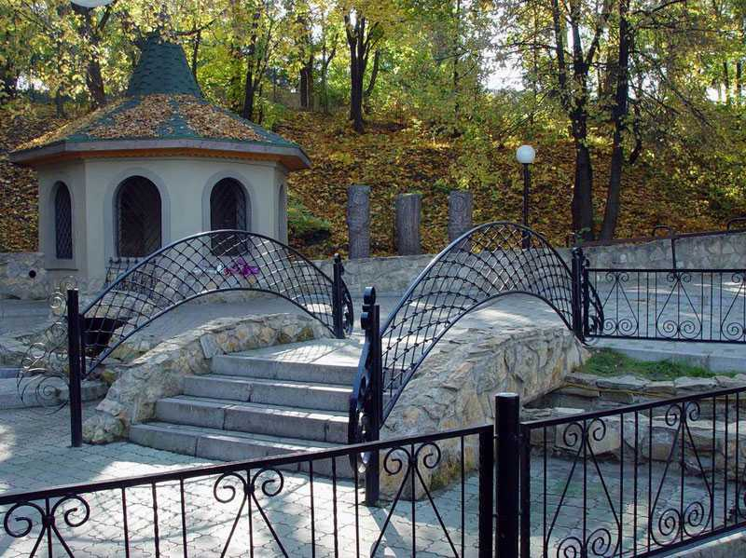
The legend about this place.
The most wonderful sight is the Red Key or Holy Spring. It is situated not far from town to the south of the Kama river. One legend says that the Muslim Imam Dauhit came there to ask the lord for a place to build a town. Also it is believed that there was a stone with Arabian inscription. It was in the 17th century.
Another legend is connected with Merchants Staheevs. They bought the property Holy Spring in 1882. The icon of Prelate Nikolay Chudotvorets is told to be found here. The Staheevs began to build the summer residence on high bank of the river Kama. The houses were surrounded with gardens, greenhouses, fountains.
A.R.Metshin is the Mayor of Nizhnekamsk. He is very popular among the people. We respect him. He tries to decide all problems which are connected with our town, its inhabitants, with ecological problems. We are proud of our town. It is young, clean, green and modern.
We are happy people because we were born, we live in this wonderful town where live our friends, parents, teachers. We love our town.

And we hope our life will be better and happier in
Nizhnekamsk!

Список использованной литературы:
1. Иванова Л.Ф., Сабирова Д.Р., Гарипова Ж.Н. “Welcome to Tatarstan”.Казань: ТАИ, 2007.-103с.
2. Архипова Л.И., Архипов В.И. “Zakamje is our native land”. Наб.Челны: ИНПО, 2006.-88с.
Использованные интернет - ресурсы:
1. Официальный сервер Республики Татарстан- www. tatar.ru
2. Официальный сайт г. Нижнекамск- www. my-nk.ru

