Тема: Welcome to London. ( Путешествие в Лондон)
Цели урока: - проверить умение учащихся воспринимать иноязычную речь учителя и одноклассников;
- развивать языковые способности учащихся;
- воспитывать у учащихся интерес и уважение к культуре и народу страны изучаемого языка;
Наглядные пособия: карточки, компьютер, курай, кроссворды.
Ход урока
1. Организационный момент.
The beginning of the lesson.
- Greeting the class and the guests.
Teacher: Good afternoon, our dear guests and my children.
Pupils: It is time to say “Hello”
It is time to say “Hi”
It’s time to say “Good Morning”
Let’s start our lesson.
2.Речевая зарядка.
Teacher: How are you?
Pupils: We are Ok, thank you.
Teacher: Are you ready to start our lesson?
Pupils: Yes, we are ready to start our lesson.
3.Сообщение темы и цели урока. Установка учителя.

Teacher: Let’s begin our lesson. The theme of our lesson today is “Welcome to London». I like to travel so much. We are going to have an interesting trip together. Do you like to travel?
Pupil: Yes, I like to travel.
Pupil: Yes, I like to travel.
Teacher: Would you like to visit foreign countries?
Pupil: Yes, I would like to visit foreign countries.
Teacher: What cities do you want to visit?
Pupil1: I want to visit Oxford.
Pupil2: I want to visit London.
Pupil3: I want to visit London too.

4. Этап актуализации знаний. Работа с лексикой
Teacher: I invite you to travel to the capital of the United Kingdom. Before we start our tour, let’s talk about London in general. What is London for you? What do we think of when we speak about London? Will you help me to make up the word web?

places of interest

Buildings, English
Museums,
Parks

London

Beautiful
Nice England
Interesting

The Queen capital

British people
(Englishmen)
Teacher: We know much about London. We start our trip with the song “Blue train”
Slowly the minutes go far away
And you won’t meet them anymore
Though the past way better
One can often say
Better life is future not before
Refrain: Faster a long the way
Goes a blue train ahead
Up to Horizon spread
Railway like a cloth
We know for sure day
Will be happy again
Soon it will come of course
Fast goes our train.

Teacher: Today we will visit many places. Look at the map. The first point is “The Reading” we go there by bus before we buy tickets. Our tickets are expensive. Let’s imagine I am your conductor and tell about yourself.
Pupils: (tell about yourself)
Teacher: Take your tickets Good luck!
Pupils: Thank you.
Teacher: We get tour to the first point. This is “Reading”. Listen to the task. Here is a short text. The sentences are in the wrong order. Put all parts of the text in the right order and read it to the class, please.

Приложение Слайд 1.
There are tourists from many countries. I come from the United Kingdom. The Queen Elizabeth II lives here too. I am English and I live in the capital of United Kingdom – London. Russian people like to visit our country and its capital too. My name is Mary. The Queen lives at Buckingham Palace. Hello! Lots of tourists come to London.
Pupil: -Hello!
- My name is Mary
- I come from the United Kingdom.
- I am English and I live in the capital of United Kingdom – London.
- The Queen Elizabeth II lives here too.
- The Queen lives at Buckingham Palace.
- Lots of tourists come to London.
- There are tourists from many countries.
- Russian people like to visit our country and its capital too.
Teacher: and so now read the text
Pupil: (read the text).
Teacher: I’ll give questions and answer on it.

Слайд 2.
- What is the girl’s name?
- What country does she come from?
- What is the capital of this country?
- Where does the Queen Elizabeth II live?
- What does Mary say about tourists?
- Can Russian tourists visit London?
Pupils: 1) Her name is Mary.
2) She comes from the United Kingdom.
3) The capital of this country is London.
4) The Queen Elizabeth II lives in Buckingham Palace.
5) Mary says that there are tourists from many countries.
6) Russian tourists can visit London.
Teacher: It is very good. And so the next place in our trip. We go there by train. The second point is “The Verb” People of the city do know the Present Simple. Help them, please do this task.

Teacher: And so the third place in our trip. We go there by train. We fly to London. How many places of interest do you know from the sixth class?
Pupil: Trafalgar Square
Pupil: Buckingham Palace.
Pupil: Hyde Park.
Pupil: Westminster Abbey.
Teacher: We will go to London and what places would you like to visit?
Pupil1: I would like to visit Trafalgar Square. The say it is the most beautiful place in London.
Pupil2: I would like to visit Buckingham Palace. I think it is wonderful building. The Queen Victoria Memorial is in front of it.
Pupil3: I would like to visit Hyde Park. There are many old and new beautiful parks in London. This park is the largest one.
Teacher: Boys and girls. You have a good chance to meet the Queen.. Are you ready to meet the Queen Elizabeth II?
Pupil: yes, we are ready.
Teacher: Before we meet the Queen Elizabeth II do our physical exercises.
Step, step, clap, clap
Step, step, clap, clap
Nod your head and turn around
And clap, clap, clap.
Teacher: Good for you! Sit down, please.
The Queen: Welcome to the British capital! Welcome to our round London sightseeing tour.Good afternoon! I’m the Queen of England, Elizabeth the Second.
Puipls: Hello the Queen Elizabeth the Second. We are glad to see you.
The Queen: Thank you very much. Where did you come from?
Pupils: We came from Bashkortostan.
The Queen: Oh, Bashkortostan. Is it far from London?
Puipl: Yes it is far from London. Bashkortostan is one of the most beautiful countries in the world. The republic is located on slopes of Southern Ural Mountains. There are very beautiful places here: mountains, rivers, fields, lakes.
The Queen: What is your national musical instrument?
Pupil: The national musical instrument is kurai?
The Queen: Is it kurai? Do you play the kurai?
Pupil: Yes, I can play.
The queen: Thank you very much. And so now watch the places of interest. (Смотр слайда)
Teacher: Then you will watch the film about London and after that you will have to do some tasks. Listen the poem and fill the missing words.

Прослушивание.
Let’s go to London.
Let’s see Trafalgar… (Square)
We’ll visit many places
And have fun there
We go to London
We see … (Big Ben)
We are very happy.
And be home then.
Teacher: What words are missing?
Pupil: I think the words Square, Big Ben
Teacher: Do you agree with your classmates?
Pupil: Yes, we agree.
Teacher: Do this task yourself. You must match the words.

1. Buckingham | a. Eye
2. Trafalgar | b. People
3. Westminster | c. Thames
4. Big | d. Bridge
5. The Tower of | e. Abbey
6. The Houses of | f. Palace
7. Tower | g. Parliament
8. London | h. Square
9. British | i. Ben
10. The river | j. London
Change your copy books and check your answers.
  - Заключительный этап урока. Подведение итогов.
It’s time to finish our lesson. My dear friends did you like our travel?
Pupil: Yes I did
Teacher: What did you like very much?
Pupil: I liked when we met the Queen Elizabeth the Second.
Pupil: I liked all of you.
Teacher: I like your work at the lesson today. You were very active. I’m pleased with your answers and work. Thank you for today’s lesson.
P,P,P your work at the lesson is good. Your mark is “5”
P,p,p,you have made some mistakes, your mark is “4”
P,P,P you mus work better, you markis “3”
  - Этап информирования учащихся. Домашнее задание.
At home you will write postcards to your friends and fill in the missing words. They are the names of places of interest in London and your names.
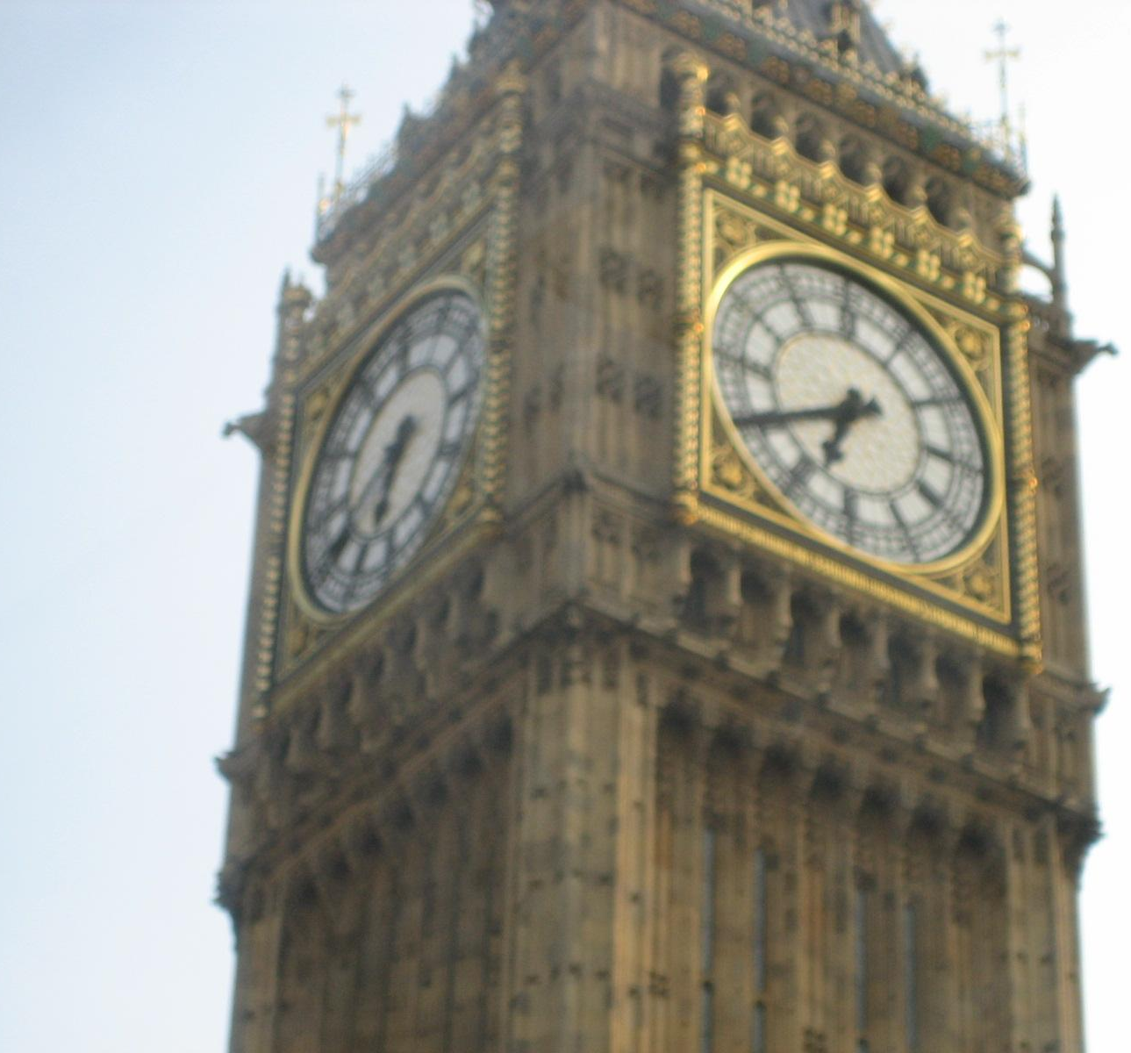

Dear -------------------!
I’m in ---------------------- now.
Yesterday I visited -------------------------------.
Also I’d like to visit -------------------------------.
London is wonderful!
I’m OK.
Bye.

The lesson is over. You may be free. Good-bye.

