ТЕСТЫ ПО АНГЛИЙСКОМУ ЯЗЫКУ

Ф.И._____________________________ КЛАСС___________

№1. Вставь слово вместо картинки.
In the zoo we can see different animals: big ………. 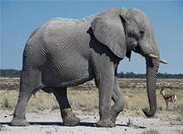 , green …………….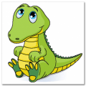, funny …………..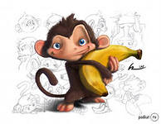, small …………….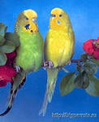, long … ……………….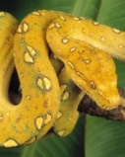 and tall ………………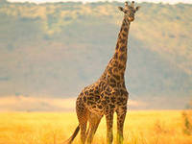.

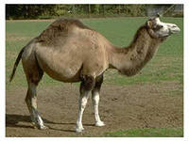 ……..lives in the desert.

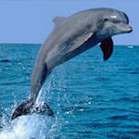…….. lives in the ocean.

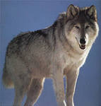…… lives in the forest.

Оценка

№2.
Reading.
Nick is twelve years old. He lives in a small town and goes to school there. There are thirty –two students in his class: seventeen boys and fifteen girls. He likes his class.
Nick has got three pets: a dog, a cat and a parrot. The dog’s name is Rex. He is five years old. He is smart. His eyes are brown and his fur is black and white. He is very friendly dog.
Nick’s cat is called Susie. She’s got green eyes and grey fur. She is very friendly, too. She is younger than Rex, she is only three years old. Susie is clean and clever.
The parrot’s name is Max. He has got small black eyes and purple fur. He is very funny.
Choose the right answer. Выберите правильный ответ
- How old is Nick?
1) 12
2)13
3)10
4)11
- How many students are there in Nick’s class?
1)14
2)21
3)32
4)34
- Does Nick like his class?
- No, he does.
- Yes, he doesn’t.
- Yes, he does.
- No, he doesn’t.
- Which pet has got black eyes?
- a dog
- a cat
- a parrot
- a dog and a cat
- What colour is Susie’s fur?
- black and white
- grey
- purple
- green
- What colour are Rex’s eyes?
- black
- green
- grey
- brown

Оценка

№3
Задание 1. Образуйте множественное число существительных.
1. A cat – four _____________ 7. A rabbit – two _______________
2. A hamster– two_____________ 8. A boy – four _______________
3. A plate – five_______________ 9. A fox – three _____________
4. A bus – four _______________ 10. A pen – five ______________
5. A mouse – three ___________ 11. A fish – two ______________
6. A wolf – two ______________ 12. A brush – three ___________

Задание 2. Впиши a, an или some.
_______ carrot ______water ______chairs
_______dog ______house ______jam
_______cats ______bread ______girl
_______milk ______books ______melon
_______skirt ______salt
_______oranges ______hat
_______ cheese ______egg

Оценка

