Олимпиада по английскому языку
4 класс
Имя, фамилия________________________________________
Класс_______________________________________________

1. Поставьте глагол to be в Present Simple.
- They … brave and happy.
- Lions …wild animals.
- My rucksack … very big.
- It … winter. It … cold.
- My mother … a teacher of Art.
- I … from Russia.
- What … you doing?
- There … 5 flowers on the table.
(8 points)

2. Поставьте предлоги on, under, in, near.
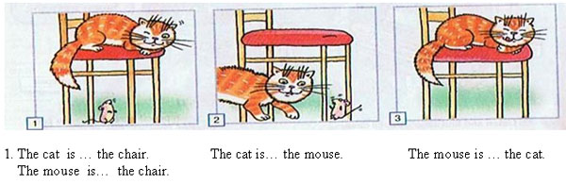
(4 points)

3. Напишите части тела весёлого монстра: eye, ear, nose, leg, arm, hand, mouth.
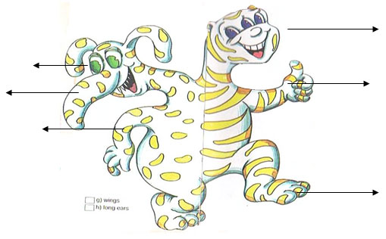
(7 points)
4. Прочитайте текст и отметьте правильные предложения
I’ve got a friend. His name is Mike. He is eleven. He is from Great Britain. He likes fishing in summer and skating in winter. He is brave and always ready to help. Mike is a pupil. His favourite subjects are Maths, Nature Study, Art and English. He can do sums, sing English songs and draw. Mike helps his mother and father after school.
1. His name is…
a) Ann
b) Bob
c) Mike
d) Lucy
2. I’ve got …
a) a dog
b) a sister
c) a book
d) a friend
3. He likes … in summer.
a) reading books
b) fishing
c) watching TV
d) skating
4. His favourite subjects are …
a) Maths, Nature Study, Art, English
b) Maths, Nature Study
c) Sport, Russian, English
d) Maths, Nature Study, Art
5. Mike helps his…..
a) friends
b) mother
c) mother and father
d) sisters
(5 points)
5. Прослушайте текст и подберите ответы
All the boys and the girls in Willie’s school love sports. In summer they go swimming and cycling and play baseball. In winter they go skating or skiing. The boys like playing hockey. His favourite game is chess. He goes to the chess club every week. He also likes painting pictures and watching video films.
- Willie likes … (sport, books, his family)
- He goes swimming in … (winter, autumn, summer)
- Chess is his … (favourite game, favourite friend, favourite film)
- He doesn’t like painting, does he? (yes, no)
(4 points)

