Составитель: Романчук И.А., МОУ лицей №6 октябрьского района городского округа город Уфа РБ, учитель английского языка

Внеклассное мероприятие, посвященное Дню смеха
Предмет: английский язык
Класс – 10 а
Учебник: English
Автор учебника: В.П. Кузовлев
Тема урока: «What’s So Funny?»
Цель: Практическая - совершенствование фонетических навыков, формирование лексических навыков, совершенствование грамматических навыков, развитие умения говорения.
Воспитательная – воспитание речевой культуры, понимание культуры других стран;
Развивающая – развитие памяти, внимания, речемыслительной активности.

Задачи: аудирование текста “TV programme” с выполнением задания на множественный выбор, активизация лексических единиц в речи, составление рассказов при помощи визуально-вербальных опор (монологическая речь).

Демонстрационный материал: DVD кадры из фильма “Golden Rush”, CD, фотографии актера, раздаточный материал

Ход мероприятия:
- Good morning, boys and girls. Glad to see you at the lesson. Let’s put aside all our routines I mean grammar exercises, lexis and reading strategies/ I suggest having some fun/ Well, today we are going to speak about jokes. By the way, do you like jokes? Do you always get them?

P: Sometimes it is difficult especially if a person speaks seriously.

- Out previous lessons were devoted to Britain and to the British. I hope you remember it. So, how can we describe the English?

P: The English are described as people with great sense of humor.

- Good. Today we are going to see is it really so. To begin with, let’s find out what a joke is?
P: A joke is something you say or do to make people laugh.

- That’s right. You know, there are lots of ways to make people laugh. And today we are going to speak about some of them. In your books you can see a Comedy Quiz. Let’s answer some questions. Before dong it try to work out the meaning of the underlined verbs. (The quiz is shown in the Appendix 1)

(Put on different voices= to pretend to have a particular way of speaking;
Dress up as different people= to put on particular clothes so to look like someone;
Make up original sketches=to say or write smth that is not true)

- All of you have mentioned the Russian comedians. Can you say what are their jokes based on?

P: They use real life situations.

- Right. And what ways of jokes do you prefer? (Pupils give different answers)
- Tonya, you have just come back from London. What can you say about the British humor?
P: It is hard to understand for foreigners. So, you have to be born in England if you want to understand their jokes at once.

- Now it’s high time to listen to the tape and find out the answer to the questions in your books. But before this I’d like you to predict the answers. (first, the group gives its answers and then listens to the tape and does the task)
(the exercise and its typescripts are in the Appendix 2)

- So, what is the answer? (A sigh “British humor” is on the board as well as the cards with cultural references and words with double meanings).
- There was a joke in the TV programme which we have already listened to. Did you get it? Well, let’s listen to it once more and be ready to answer what the joke is based on.

(The joke on the tape: 1) - Waiter, waiter, what’s this? (The joke can be shown on the board)
- It’s bean soup, sir.
- I don’t care what it’s been. I want to know what it is now.

P: This joke is based on homophones.

- Have you ever heard other British jokes?

P: I have seen a joke in the Internet. It sounds like this: An American student arrives in London on a rainy day. He wakes up the next day and it is raining. It also rains the day after that, and the day after that. Going out for lunch, he sees a child and asks, “ Hey, kid! Does it ever stop raining around here?” – “ How should I know? I’m only 8”

P: Here we can see the weather peculiarity.

- I hope these points will help you in doing the following task. Now you have got a chance to use your knowledge in making up jokes. It’s time to work in pairs. I’m going to give you the sheets of paper. The task is different for each pair. Pair 1 is going to make up a story using the picture. Pair 2 is to open the brackets in the given sentences and then to tell the story. Pair 3 is to put the sentences in order and then retell the joke. The task for Pair 4 is to match the beginning and the ending of some jokes. (Examples are given in the Appendix 3)

-Great! Your stories are perfect!

-Today we are telling jokes. But when the movies were silent (it is called a silent ear) all jokes were shown on the screen. People could watch the actors playing the jokes but couldn’t hear them. While listening to the TV programme we mentioned one of the famous actors of the silent movies. His photos you can see on the board. Do you remember his name? (Charles Chaplin). Why did he achieve an international success?

P: His jokes were visual and he showed the situations from a daily life.

- Now it’s time to watch some pictures from the film “The Gold Rush”. While watching these episodes try to answer the question what was so funny about his jokes?

(His manner to walk, his way of dressing up, his image, characters get into troubles and then get out of then in a funny way)

- Did you like the film? Yes, it is great. His way of getting out of the situations cracked people up. Where there any funny situations in your life? How did you get put of them?

P: Once my granddad decided to hang a picture on the wall. After he had nailed the picture, our neighbor wondered if ne could use the other end of the nail.

P: One day I was playing football with my friend. Unfortunately, my mother decided to open the window just when I passed the ball to my friend. The ball went into the opened window and broke the mirror. I said to my mum:” It wasn’t me! It was my friend! He ducked when I passed the ball at him”

Unfortunately, our lesson is coming to an end. Let’s sum up. What new things did you learn today?

P: We spoke about some facts about the British humor and got acquainted with a famous person C. Chaplin.

P: Tried to make up short and long jokes and funny stories, had listening practice with multiple-choice answering.

Your answers were good enough. Thank you very much for the lesson. Good bye.

Appendix 1

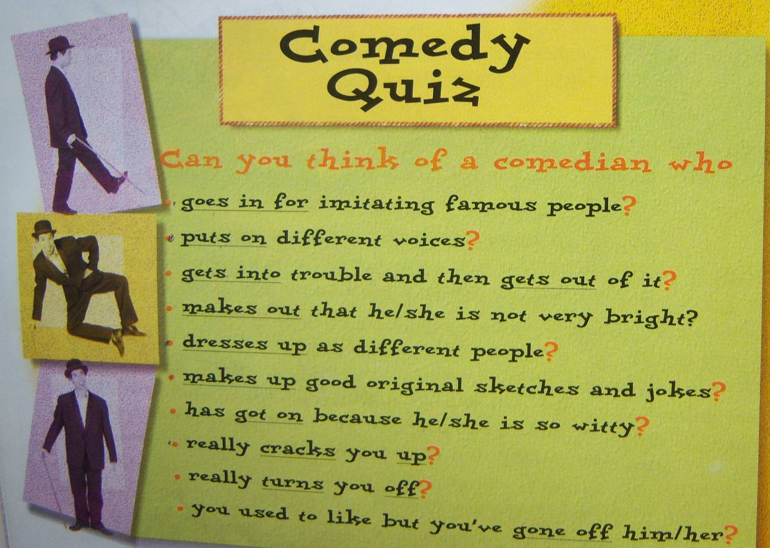

Appendix 2
Typescript

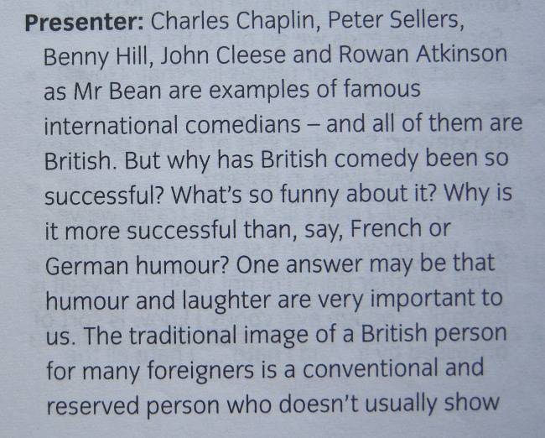
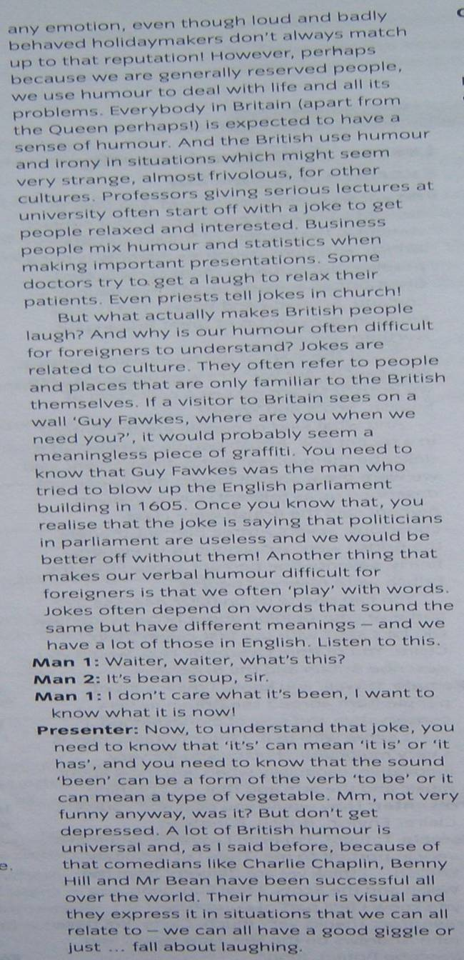

The exercise for the typescript

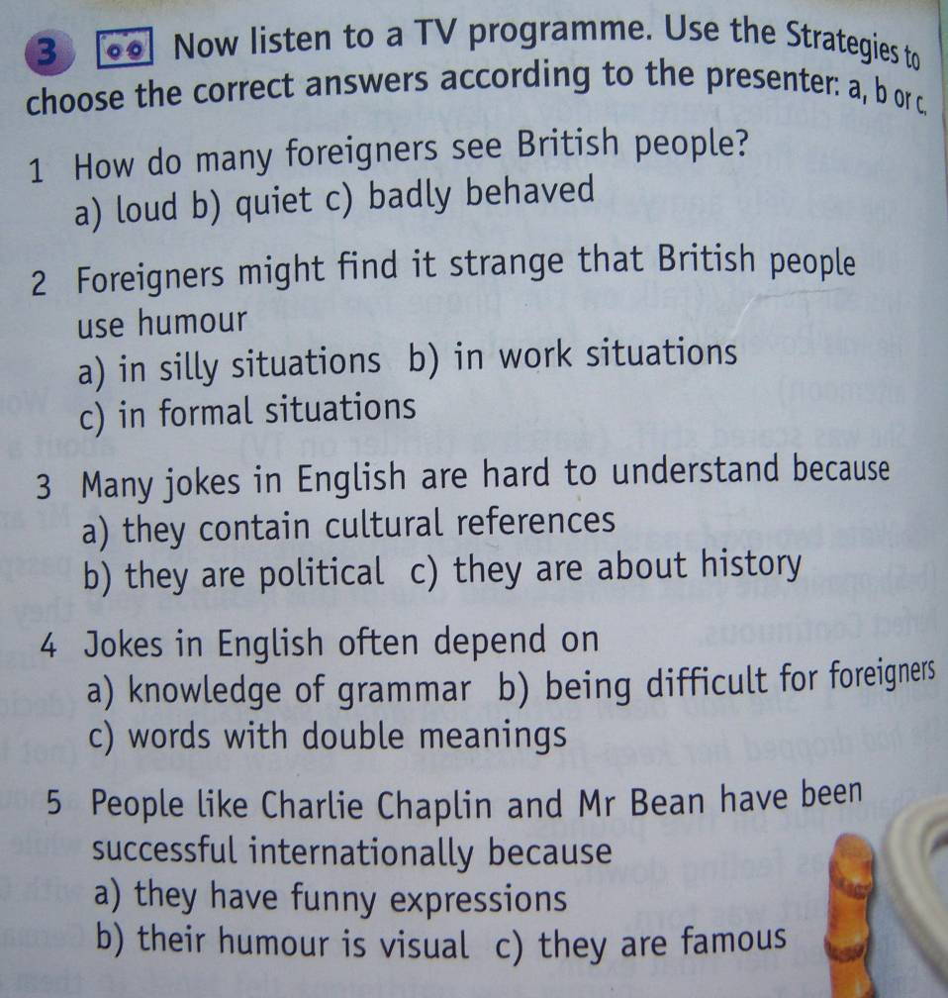

Appendix 3. Pair 1. Make up a story using the picture and the words above it.

To walk along the beach, suddenly, to see far in the water, to decide, to swim fast, a very expensive watch, to be interested in, to save, to leave, to get, to run away,

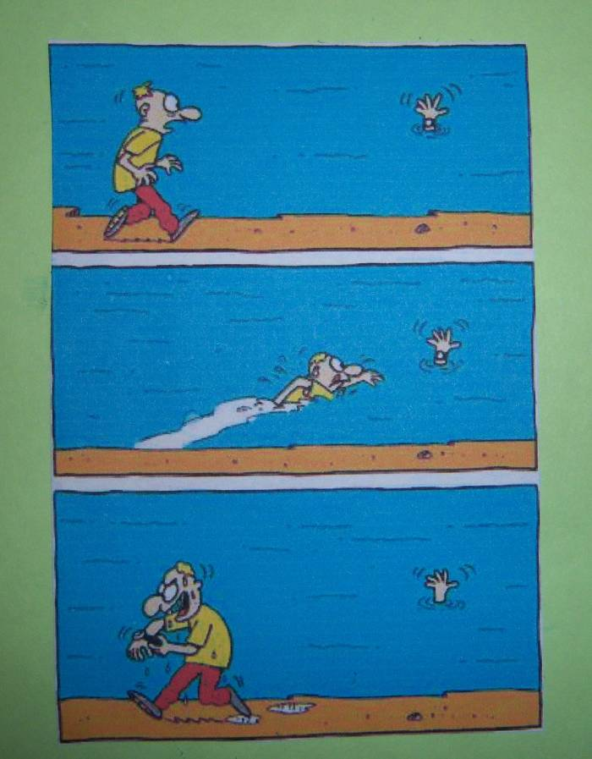

Pair 2.
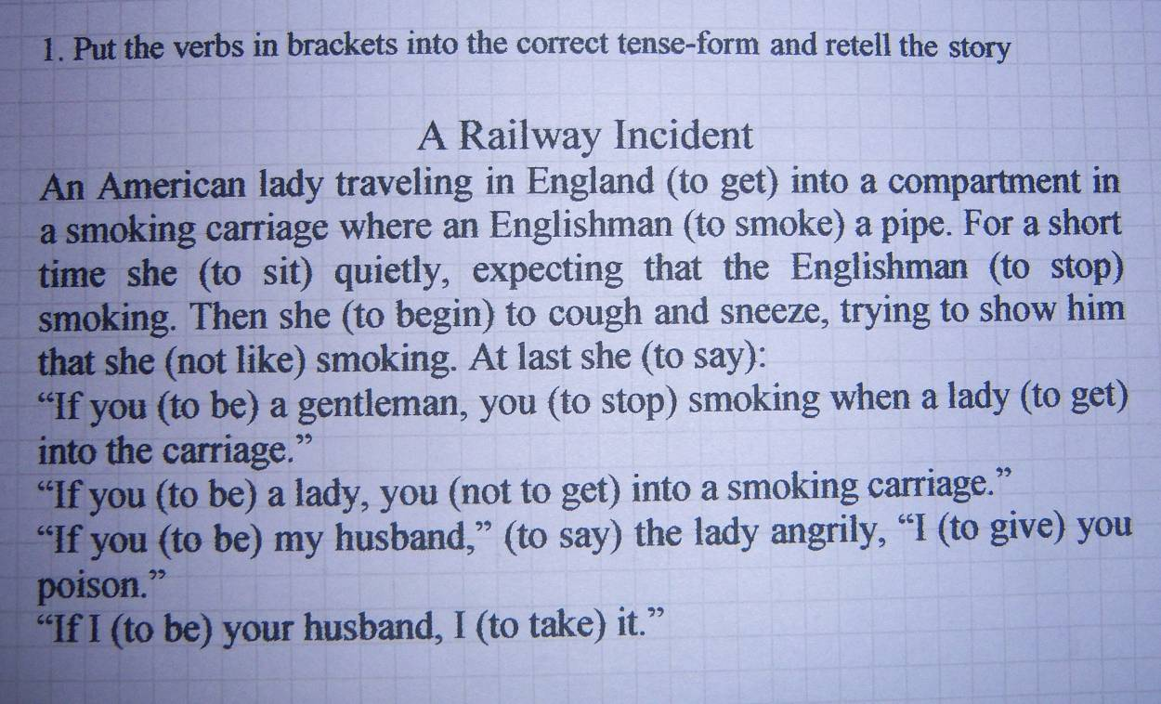

Pair 3. Put the sentences in the correct order

a) Sometimes later the Judge asked the man why he was arrested

b) One day a policeman stopped a suspicious man and asked him what he was doing in the street at night.

c) and that “Trouble” was his dog’s name.

d) The poor thing said that he was looking for trouble.

e) After that the officer told the man to follow him.

f) The man answered that he was looking for trouble.

Pair 4. Match the beginning and the ending of the jokes.

- I’m looking for a man with a  wooden leg called Johnson. | A | - About six carriage, sir.
- Guard! How long will the next train be? | B | -Certainly not. You’ll have turkey, like everybody else!
- Can I have a puppy for Christmas? | C | - He had no body to go with.
- Why couldn’t a skeleton go to the  Christmas party? | D | - You know my father doesn’t like you  hanging around
-If you don’t sat you’ll marry me I’ll hang  myself from that tree in front of your house | E | -Have you seen a doctor?
- I keep seeing little black dots before my eyes… | F | -What’s his other leg called?

